**BAB V**

**IMPLEMENTASI DAN PENGUJIAN SISTEM**

* 1. **Implementasi Sistem**

Sistem Informasi persedian barang untuk prediksi barang paring laku pada Toko Alisha Mart yang telah dirancang merupakan sebuah web aplikasi yang menggunakan Bahasa Pemrograman *Hypertext Preprocessor* (PHP) yang dibangun untuk memprediksi data paling laku atau terlaris berdasarkan barang yang paling sering dibeli selama 9 minggu. Aplikasi ini menggunakan metode *Association Rule* menggunakan algoritma *Apriori.*

* + 1. **Tampilan Halaman *Login***

Halaman *login* merupakan halaman yang pertama kali muncul pada saat aplikasi dijalankan. Halaman *login* ini menerima masukan *username* dan *password.*. Tampilan halaman *login* dapat dilihat pada Gambar 5.1.

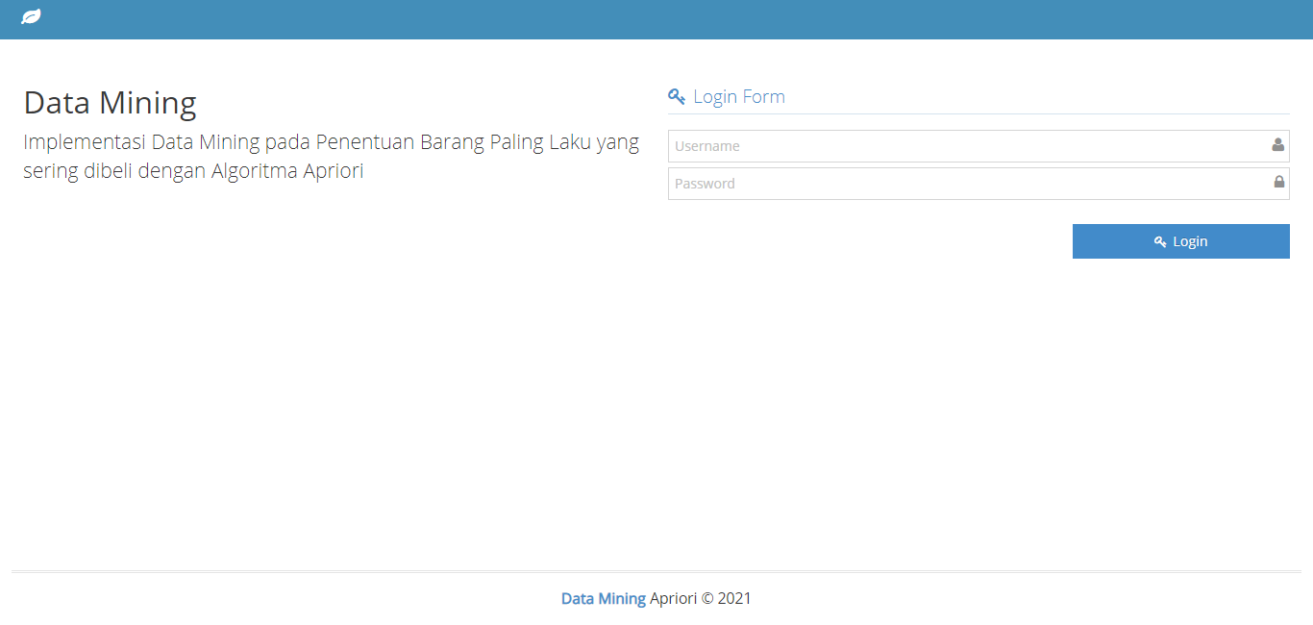

**Gambar 5.1 Tampilan Halaman *Login***

* + 1. **Tampilan Halaman Utama**

Pada halaman ini setelah *login* terdapat list halaman menu pada sebelah kiri layar. Seperti yang dapat dilihat pada Gambar 5.2.

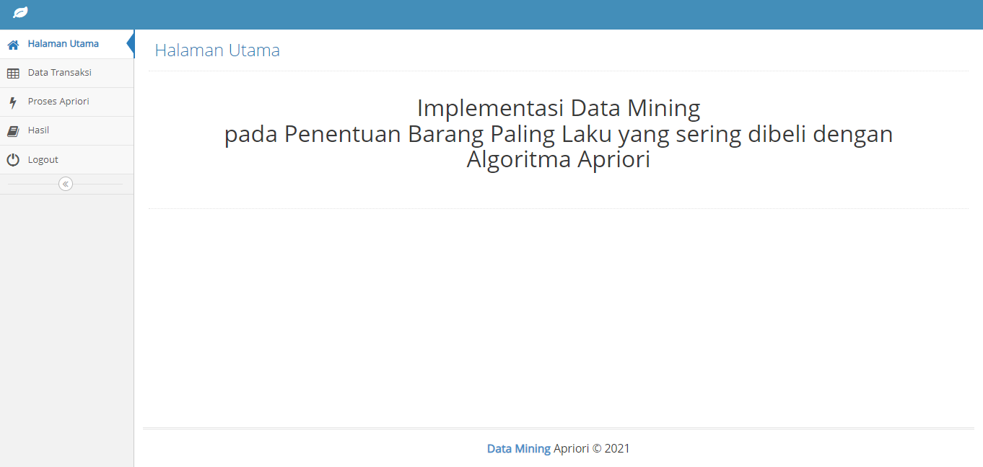

**Gambar 5.2 Tampilan Halaman Utama**

* + 1. **Tampilan Data Transaksi**

Pada tampilan halaman menu data transaksi ini *user* dapat mengelola data barang seperti melihat, menambah, dan menghapus data transaksi. Seperti yang dapat dilihat pada Gambar 5.3.

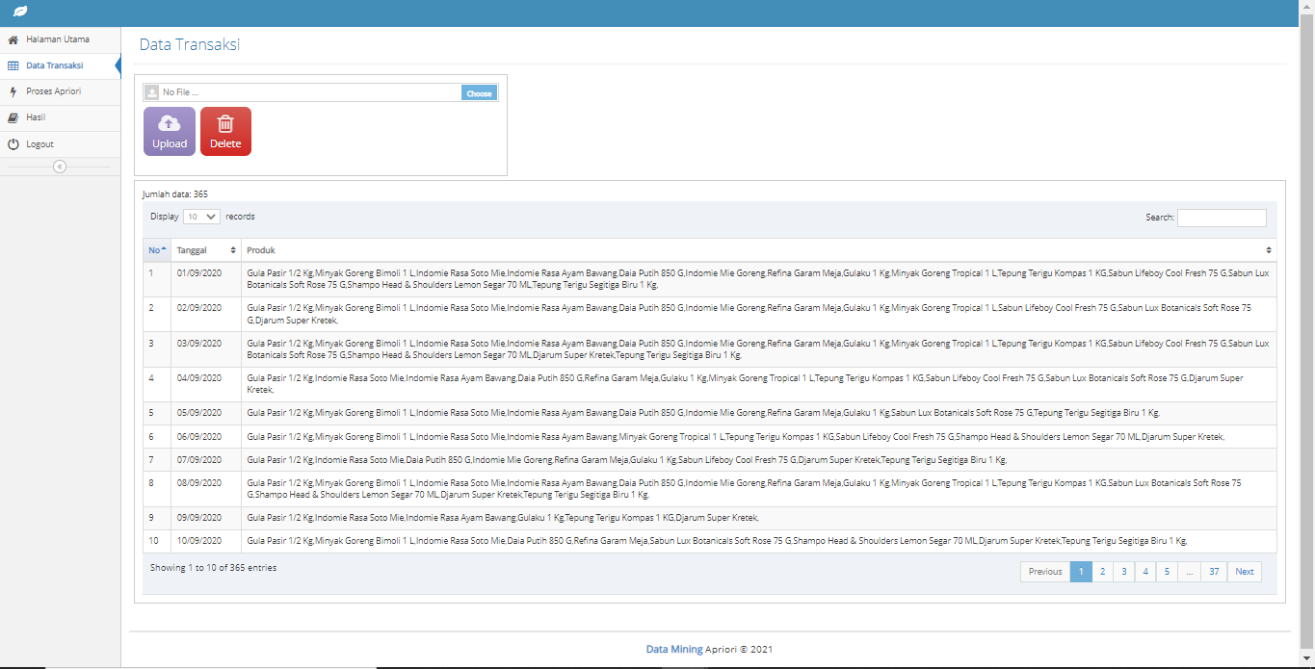

**Gambar 5.3 Tampilan Halaman Data Transaksi**

* + 1. **Tampilan Proses *Apriori***

Pada halaman menu proses *apriori, user* dapat melakukan proses prediksi barang paling laku untuk minggu berikutnya berdasarkan *min support* dan *min confidence* yang ditentukan. Dapat dilihat pada gambar 5.4.

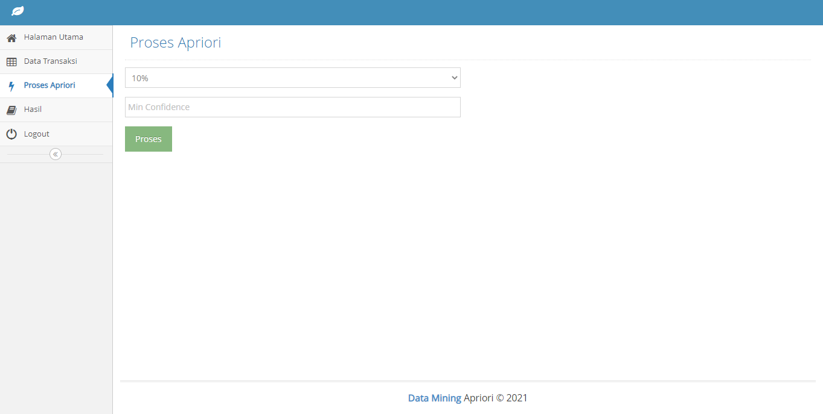

**Gambar 5.4 Tampilan Proses *Apriori***

* + 1. **Tampilan Halaman Hasil**

Pada halaman menu hasil*, user* dapat melihat riwayat hasil dari prediksi barang paling laku dan mecetak hasil dari prediksi barang paling laku. Dapat dilihat pada gambar 5.5.

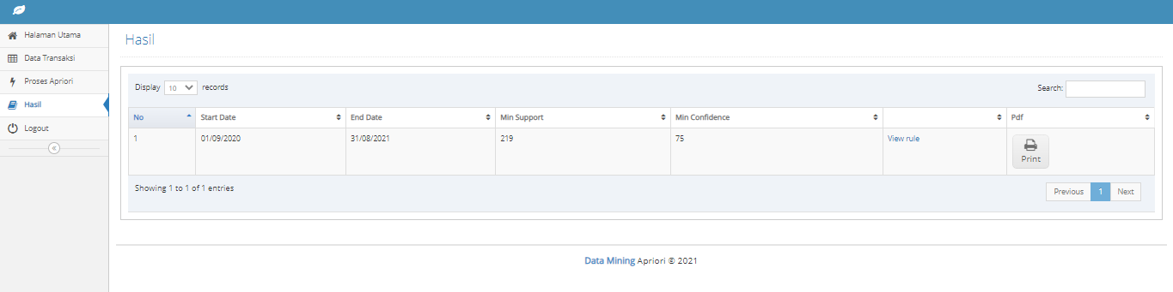

**Gambar 5.5 Tampilan Halaman Hasil**

* 1. **Pengujian Sistem**

Pengujian merupakan tahap yang utama dalam pembuatan suatu aplikasi. Hasil dari pengujian yang telah didapatkan akan dijadikan sebagai tolak ukur dalam proses pengembangan selanjutnya.

* + 1. **Pengujian *Black Box***

Pengujian *black box* dilakukan dengan menguji perangkat lunak dari segi fungsionalitas perangkat lunak. Fungsionalitas perangkat lunak yang diuji sesuai dengan skenario pada tahap desain.

**Tabel 5.1 Pengujian *Black Box***

|  |  |  |
| --- | --- | --- |
| **Input/Event** | **Output** | **Hasil Uji** |
| Melakukan *login* dengan mengisi *Username* dan *password* (dengan akun user yang sudah terdaftar) lalu menekan tombol *Login* | Halaman *user* masuk | Sesuai |
| Memilih menu Data Transaksi | Menampilkan halaman data transaksi | Sesuai |
| Memilih tombol / kolom *choose*, memilih file data transaksi, dan pilih tombol *upload* | Sistem akan menerima file data transaksi dan menambahkan ke dalam data transaksi | Sesuai |
| Memilih tombol *delete,* kemudian pilih tombol ok | Sistem akan menerima perintah dan menghapus seluruh data transaksi | Sesuai |
| Memilih halaman menu Proses *Apriori* | Menampilkan halaman Proses *Apriori* | Sesuai |
| Memilih kolom tanggal tentukan periode prediksi, lalu pilih tombol *search* | Menampilkan data transaksi berdasarkan periode dipilih | Sesuai |
| Mengisi nilai min *support* dan min *confidence,* lalu pilih tombol proses | Sistem akan menampilkan hasil dari prediksi barang paling laku sesuai dengan nilai min *support* dan min *confidence* | Sesuai |
| Memilih halaman menu Hasil | Menampilkan halaman Hasil | Sesuai |
| Pilih *view rule* di halaman menu Hasil | Sistem akan m | Sesuai |
| Memilih tombol *icon print* di halaman menu Hasil | Menampilkan hasil prediksi barang paling laku, *user* dapat mencetak hasil prediksi barang paling laku | Sesuai |

* + 1. **Pengujian Manual Algoritma *Apriori***

Alur perhitungan penerapan Algoritma *Apriori* untuk prediksi barang paling laku atau sering dibeli adalah sebagai berikut:

Dari banyaknya data transaksi, diambil 32 data transaksi untuk dijadikan sempel perhitungan manual algoritma *Apriori*. Pada pengujian secara manual ini dilakukan secara bertahap, tahap pertama data transaksi pada Toko Alisha Mart diakumulasikan. Akumulasi data barang keluar tersebut di peroleh dari total penjualan perhari Toko Alisha Mart.

**Tabel 5.2 Data Transaksi**

|  |  |  |  |  |  |  |  |  |  |  |  |  |  |  |  |  |  |  |  |  |  |  |  |  |  |  |  |  |  |  |  |  |  |
| --- | --- | --- | --- | --- | --- | --- | --- | --- | --- | --- | --- | --- | --- | --- | --- | --- | --- | --- | --- | --- | --- | --- | --- | --- | --- | --- | --- | --- | --- | --- | --- | --- | --- |
| **No** | **NAMA BARANG** | **#** | **#** | **#** | **#** | **#** | **#** | **#** | **#** | **#** | **#** | **#** | **#** | **#** | **#** | **#** | **#** | **#** | **#** | **#** | **#** | **#** | **#** | **#** | **#** | **#** | **#** | **#** | **#** | **#** | **#** | **#** | **#** |
| 1 | Minyak Goreng Bimoli 1 L | 0 | 0 | 0 | 0 | 0 | 0 | 0 | 0 | 0 | 0 | 0 | 0 | 0 | 0 | 0 | 0 | 0 | 0 | 0 | 0 | 0 | 0 | 0 | 0 | 0 | 0 | 0 | 0 | 1 | 0 | 0 | 1 |
| 2 | Gula Pasir SetKg | 0 | 0 | 0 | 0 | 0 | 0 | 0 | 0 | 0 | 0 | 0 | 0 | 0 | 0 | 0 | 0 | 0 | 0 | 0 | 0 | 0 | 0 | 0 | 0 | 0 | 0 | 0 | 0 | 1 | 0 | 0 | 0 |
| 3 | Tepung Terigu Kompas 1 KG | 0 | 0 | 0 | 0 | 0 | 0 | 0 | 0 | 0 | 0 | 0 | 0 | 0 | 0 | 0 | 0 | 0 | 0 | 0 | 1 | 0 | 0 | 1 | 0 | 0 | 0 | 0 | 0 | 0 | 0 | 0 | 0 |
| 4 | Luwak White Kopi 20g | 0 | 0 | 0 | 1 | 0 | 0 | 0 | 0 | 0 | 0 | 0 | 0 | 0 | 0 | 0 | 0 | 0 | 0 | 0 | 1 | 0 | 0 | 1 | 0 | 0 | 0 | 0 | 0 | 1 | 0 | 0 | 0 |
| 5 | Garuda Kacang Telur | 0 | 1 | 0 | 0 | 0 | 0 | 0 | 0 | 1 | 0 | 0 | 0 | 0 | 0 | 1 | 1 | 0 | 0 | 0 | 0 | 0 | 0 | 0 | 0 | 0 | 0 | 0 | 0 | 0 | 0 | 0 | 0 |
| 6 | Oishi Makado Sapi Panggang | 1 | 0 | 0 | 0 | 0 | 0 | 0 | 0 | 1 | 0 | 0 | 1 | 0 | 0 | 0 | 0 | 0 | 0 | 0 | 0 | 0 | 0 | 0 | 0 | 0 | 0 | 0 | 0 | 0 | 0 | 0 | 0 |
| 7 | Potabe Ayam Bakar | 0 | 0 | 0 | 0 | 0 | 0 | 0 | 0 | 0 | 0 | 0 | 1 | 0 | 1 | 1 | 0 | 0 | 0 | 0 | 0 | 0 | 0 | 0 | 0 | 0 | 0 | 0 | 0 | 0 | 0 | 0 | 0 |
| 8 | Potabe Beef BBQ | 1 | 0 | 0 | 0 | 0 | 0 | 1 | 0 | 1 | 0 | 0 | 0 | 0 | 0 | 0 | 0 | 0 | 0 | 0 | 0 | 0 | 0 | 0 | 0 | 0 | 0 | 0 | 0 | 0 | 0 | 0 | 0 |
| 9 | Roma Malkis Abon | 1 | 0 | 0 | 0 | 0 | 0 | 1 | 0 | 0 | 0 | 0 | 0 | 0 | 1 | 0 | 0 | 0 | 0 | 0 | 0 | 0 | 0 | 0 | 0 | 0 | 0 | 0 | 0 | 1 | 1 | 0 | 1 |
| 10 | Roma Malkis Cracker | 0 | 0 | 0 | 0 | 0 | 0 | 0 | 0 | 0 | 0 | 0 | 0 | 0 | 0 | 0 | 0 | 0 | 1 | 1 | 0 | 0 | 0 | 0 | 0 | 0 | 0 | 0 | 0 | 0 | 0 | 0 | 0 |
| 11 | Slai Olai Selai Strawberry | 0 | 0 | 0 | 0 | 0 | 0 | 0 | 0 | 0 | 0 | 0 | 0 | 0 | 0 | 0 | 0 | 0 | 0 | 0 | 0 | 0 | 0 | 0 | 1 | 1 | 0 | 0 | 0 | 0 | 0 | 0 | 0 |
| 12 | Tictac | 0 | 0 | 0 | 0 | 0 | 0 | 0 | 0 | 0 | 0 | 0 | 0 | 0 | 0 | 0 | 0 | 0 | 1 | 0 | 0 | 0 | 1 | 0 | 0 | 0 | 0 | 0 | 0 | 0 | 0 | 0 | 0 |
| 13 | Indomie Mie Goreng | 0 | 1 | 1 | 1 | 0 | 0 | 0 | 0 | 0 | 0 | 0 | 0 | 0 | 0 | 0 | 0 | 1 | 1 | 0 | 0 | 0 | 0 | 0 | 0 | 0 | 1 | 1 | 1 | 0 | 0 | 0 | 0 |
| 14 | Indomie Rasa Ayam Bawang | 0 | 0 | 1 | 0 | 0 | 0 | 0 | 0 | 0 | 0 | 0 | 0 | 0 | 1 | 0 | 1 | 0 | 0 | 1 | 1 | 0 | 0 | 0 | 0 | 0 | 0 | 0 | 0 | 1 | 0 | 1 | 1 |
| 15 | Clevo Coklat 115 ML | 0 | 0 | 1 | 0 | 0 | 0 | 0 | 0 | 0 | 0 | 0 | 0 | 0 | 0 | 0 | 1 | 0 | 0 | 0 | 0 | 0 | 0 | 0 | 0 | 0 | 0 | 0 | 0 | 0 | 0 | 0 | 0 |
| 16 | Good Day | 0 | 0 | 1 | 1 | 0 | 0 | 0 | 0 | 1 | 0 | 0 | 0 | 0 | 0 | 0 | 0 | 1 | 0 | 1 | 0 | 1 | 0 | 0 | 0 | 0 | 0 | 0 | 0 | 0 | 0 | 1 | 1 |
| 17 | Air Mineral Vit 600 ML | 0 | 1 | 0 | 0 | 1 | 0 | 1 | 0 | 0 | 0 | 0 | 0 | 0 | 0 | 0 | 0 | 0 | 1 | 0 | 0 | 1 | 0 | 0 | 0 | 0 | 0 | 0 | 0 | 0 | 1 | 0 | 0 |
| 18 | Air Mineral Le Mineral 600 ML | 0 | 1 | 0 | 0 | 0 | 0 | 0 | 0 | 0 | 0 | 0 | 1 | 0 | 0 | 1 | 1 | 0 | 0 | 0 | 0 | 0 | 0 | 0 | 0 | 1 | 0 | 1 | 1 | 0 | 0 | 0 | 0 |
| 19 | Teh Pucuk | 0 | 0 | 0 | 0 | 0 | 1 | 1 | 0 | 0 | 0 | 0 | 0 | 0 | 0 | 1 | 1 | 0 | 1 | 0 | 0 | 0 | 0 | 0 | 0 | 1 | 0 | 0 | 1 | 0 | 0 | 0 | 0 |
| 20 | Sprite 250ML | 0 | 0 | 1 | 0 | 0 | 0 | 1 | 0 | 0 | 0 | 0 | 0 | 0 | 0 | 0 | 0 | 0 | 0 | 0 | 0 | 0 | 1 | 0 | 1 | 0 | 0 | 0 | 0 | 0 | 0 | 0 | 0 |
| 21 | You.C1000 orange 140 ml | 1 | 0 | 0 | 0 | 0 | 0 | 0 | 0 | 0 | 0 | 0 | 1 | 0 | 0 | 0 | 0 | 0 | 0 | 0 | 0 | 0 | 0 | 0 | 0 | 0 | 0 | 0 | 0 | 0 | 0 | 0 | 0 |
| 22 | Laurier Active Day 22 CM 8buah | 0 | 0 | 1 | 0 | 0 | 0 | 0 | 0 | 0 | 0 | 0 | 0 | 0 | 0 | 0 | 0 | 0 | 0 | 0 | 0 | 0 | 0 | 0 | 0 | 0 | 0 | 0 | 0 | 0 | 0 | 0 | 0 |
| 23 | Rapika 3 In 1 Korean Kamelia | 0 | 0 | 1 | 0 | 0 | 0 | 0 | 0 | 0 | 0 | 0 | 0 | 0 | 1 | 0 | 0 | 0 | 0 | 0 | 0 | 0 | 0 | 0 | 0 | 0 | 0 | 0 | 0 | 0 | 0 | 0 | 0 |
| 24 | Pepsodent Action 190 G | 0 | 0 | 0 | 0 | 1 | 0 | 0 | 0 | 0 | 0 | 0 | 0 | 0 | 0 | 0 | 0 | 0 | 0 | 0 | 0 | 0 | 0 | 0 | 0 | 0 | 0 | 0 | 0 | 0 | 0 | 0 | 0 |
| 25 | LA Bold | 0 | 0 | 0 | 0 | 0 | 0 | 1 | 0 | 0 | 0 | 0 | 0 | 0 | 0 | 0 | 0 | 0 | 1 | 0 | 0 | 0 | 0 | 0 | 0 | 1 | 0 | 0 | 1 | 0 | 0 | 0 | 0 |
| 26 | Djarum Super Kretek | 0 | 1 | 0 | 1 | 1 | 0 | 0 | 0 | 1 | 0 | 1 | 1 | 0 | 1 | 0 | 1 | 0 | 1 | 0 | 0 | 0 | 0 | 0 | 0 | 0 | 0 | 0 | 0 | 0 | 0 | 0 | 0 |
| 27 | Clas mild | 1 | 0 | 0 | 0 | 0 | 0 | 0 | 1 | 0 | 0 | 0 | 0 | 0 | 0 | 0 | 0 | 1 | 0 | 0 | 0 | 0 | 0 | 0 | 0 | 0 | 0 | 0 | 0 | 1 | 1 | 0 | 0 |
| 28 | Sampoerna Kretek | 0 | 0 | 0 | 0 | 0 | 1 | 0 | 0 | 0 | 1 | 1 | 0 | 0 | 0 | 1 | 0 | 0 | 0 | 1 | 0 | 0 | 0 | 0 | 0 | 0 | 0 | 0 | 0 | 0 | 0 | 0 | 0 |
| 29 | Magnum Filter | 0 | 0 | 0 | 0 | 0 | 0 | 0 | 0 | 0 | 0 | 0 | 0 | 0 | 0 | 0 | 0 | 0 | 0 | 0 | 0 | 0 | 0 | 0 | 1 | 0 | 1 | 0 | 0 | 0 | 0 | 0 | 0 |
| 30 | Sampoerna Mild | 0 | 0 | 0 | 0 | 0 | 0 | 0 | 0 | 0 | 0 | 0 | 0 | 0 | 0 | 0 | 0 | 0 | 0 | 0 | 0 | 0 | 1 | 1 | 0 | 0 | 0 | 1 | 0 | 0 | 0 | 1 | 1 |
| 31 | Ultra Milk Coklat 250 ML | 0 | 0 | 0 | 0 | 0 | 0 | 0 | 0 | 0 | 0 | 0 | 0 | 0 | 0 | 0 | 0 | 0 | 0 | 0 | 0 | 1 | 0 | 0 | 0 | 0 | 0 | 1 | 0 | 0 | 0 | 0 | 0 |
| 32 | Buavita Leci | 0 | 0 | 1 | 0 | 0 | 0 | 0 | 0 | 0 | 0 | 0 | 0 | 0 | 0 | 0 | 0 | 0 | 0 | 0 | 0 | 0 | 0 | 0 | 0 | 0 | 0 | 0 | 0 | 0 | 0 | 0 | 0 |
| 33 | Sukro Original | 0 | 1 | 0 | 0 | 0 | 0 | 0 | 0 | 0 | 1 | 0 | 0 | 0 | 0 | 0 | 0 | 0 | 0 | 0 | 0 | 0 | 0 | 0 | 0 | 0 | 0 | 0 | 0 | 0 | 0 | 0 | 0 |
| 34 | Garuda Pilus | 0 | 0 | 0 | 0 | 0 | 0 | 0 | 0 | 0 | 0 | 1 | 0 | 0 | 0 | 0 | 0 | 0 | 0 | 0 | 0 | 0 | 0 | 0 | 0 | 0 | 0 | 0 | 0 | 0 | 1 | 0 | 0 |
| 35 | Lays Rumput Laut | 0 | 0 | 0 | 0 | 0 | 0 | 0 | 0 | 0 | 0 | 0 | 0 | 0 | 0 | 1 | 0 | 1 | 0 | 0 | 0 | 0 | 0 | 0 | 0 | 0 | 0 | 0 | 0 | 0 | 0 | 1 | 1 |
| 36 | Oishi Pop Corn Caramel | 0 | 0 | 0 | 1 | 0 | 0 | 0 | 0 | 0 | 0 | 0 | 0 | 0 | 0 | 0 | 0 | 0 | 0 | 0 | 1 | 1 | 0 | 0 | 0 | 0 | 0 | 0 | 0 | 0 | 0 | 0 | 0 |
| 37 | Potabe Grilled Seaweed | 0 | 0 | 0 | 0 | 0 | 0 | 0 | 0 | 0 | 0 | 0 | 0 | 0 | 0 | 0 | 0 | 0 | 0 | 0 | 0 | 0 | 0 | 0 | 0 | 0 | 0 | 0 | 0 | 0 | 1 | 0 | 0 |
| 38 | Roma Malkis Coklat | 0 | 0 | 0 | 0 | 0 | 1 | 0 | 1 | 0 | 0 | 0 | 0 | 0 | 0 | 0 | 0 | 0 | 0 | 0 | 0 | 0 | 0 | 0 | 0 | 0 | 1 | 0 | 0 | 0 | 0 | 0 | 1 |
| 39 | Kuaci Rebo Green Tea | 0 | 0 | 0 | 0 | 0 | 0 | 0 | 0 | 0 | 0 | 1 | 0 | 0 | 0 | 0 | 0 | 0 | 0 | 1 | 0 | 0 | 0 | 0 | 0 | 0 | 0 | 0 | 0 | 0 | 0 | 0 | 0 |
| 40 | Roma Sari Gandum 149 G | 0 | 0 | 0 | 0 | 0 | 0 | 0 | 1 | 0 | 0 | 0 | 0 | 1 | 0 | 0 | 0 | 0 | 0 | 1 | 0 | 0 | 1 | 0 | 0 | 0 | 0 | 0 | 0 | 0 | 0 | 0 | 0 |
| 41 | Gerry Salut Double Coklat | 0 | 0 | 0 | 0 | 0 | 0 | 0 | 0 | 0 | 0 | 0 | 0 | 0 | 0 | 0 | 0 | 1 | 0 | 0 | 0 | 0 | 0 | 0 | 0 | 0 | 0 | 0 | 0 | 0 | 0 | 0 | 0 |
| 42 | Slai Olai Selai Blueberry | 0 | 1 | 1 | 0 | 0 | 1 | 0 | 1 | 0 | 0 | 0 | 0 | 0 | 0 | 0 | 0 | 0 | 0 | 0 | 0 | 0 | 0 | 0 | 0 | 0 | 1 | 0 | 0 | 0 | 0 | 0 | 0 |
| 43 | Indomie Rasa Kari Ayam | 0 | 0 | 0 | 0 | 0 | 0 | 0 | 0 | 0 | 0 | 0 | 0 | 0 | 0 | 0 | 0 | 1 | 0 | 0 | 0 | 0 | 0 | 1 | 0 | 0 | 0 | 0 | 0 | 0 | 1 | 1 | 1 |
| 44 | Indomie Rasa Soto Mie | 0 | 0 | 1 | 1 | 0 | 0 | 0 | 0 | 0 | 0 | 0 | 0 | 1 | 0 | 0 | 0 | 1 | 0 | 0 | 0 | 0 | 0 | 0 | 1 | 0 | 0 | 0 | 0 | 0 | 0 | 0 | 1 |
| 45 | Air Mineral Aqua 1500mL | 0 | 0 | 1 | 1 | 0 | 1 | 0 | 0 | 0 | 0 | 0 | 0 | 0 | 0 | 0 | 0 | 0 | 0 | 1 | 0 | 0 | 0 | 0 | 0 | 0 | 0 | 0 | 0 | 1 | 0 | 0 | 0 |
| 46 | Air Mineral Le Mineral 1500mL | 0 | 0 | 0 | 0 | 0 | 0 | 0 | 1 | 0 | 0 | 0 | 0 | 0 | 0 | 0 | 0 | 1 | 0 | 0 | 0 | 0 | 1 | 0 | 0 | 0 | 1 | 0 | 0 | 0 | 0 | 1 | 0 |
| 47 | Air Miineral Vit 1500mL | 0 | 0 | 0 | 0 | 0 | 0 | 0 | 0 | 0 | 1 | 0 | 0 | 0 | 0 | 0 | 0 | 0 | 0 | 0 | 0 | 0 | 0 | 0 | 0 | 0 | 0 | 0 | 0 | 0 | 0 | 0 | 0 |
| 48 | Freshtea Apel | 0 | 1 | 0 | 0 | 0 | 0 | 0 | 0 | 0 | 0 | 0 | 0 | 0 | 0 | 0 | 0 | 1 | 0 | 0 | 0 | 0 | 0 | 0 | 1 | 0 | 0 | 0 | 0 | 0 | 1 | 0 | 1 |
| 49 | Freshtea Madu | 1 | 0 | 0 | 0 | 0 | 0 | 0 | 0 | 0 | 1 | 1 | 0 | 0 | 0 | 0 | 0 | 0 | 0 | 0 | 0 | 0 | 0 | 0 | 0 | 0 | 0 | 0 | 0 | 0 | 0 | 0 | 0 |
| 50 | Larutan Cap Kaki Tiga Jeruk 320ml | 0 | 0 | 1 | 0 | 0 | 0 | 0 | 0 | 0 | 0 | 0 | 0 | 1 | 0 | 0 | 0 | 0 | 0 | 0 | 0 | 0 | 0 | 0 | 0 | 0 | 0 | 0 | 0 | 0 | 0 | 0 | 0 |
| 51 | Sabun Colek Ekonomi Putih 435 G | 0 | 0 | 0 | 0 | 0 | 0 | 0 | 0 | 0 | 0 | 0 | 0 | 0 | 0 | 0 | 0 | 0 | 0 | 0 | 1 | 0 | 0 | 0 | 0 | 0 | 0 | 0 | 0 | 0 | 0 | 0 | 0 |
| 52 | Wipol Karbol Lemon | 0 | 0 | 0 | 1 | 0 | 0 | 0 | 0 | 0 | 0 | 0 | 0 | 1 | 0 | 0 | 0 | 0 | 0 | 0 | 1 | 0 | 0 | 1 | 0 | 0 | 0 | 0 | 0 | 0 | 0 | 0 | 1 |
| 53 | Pepsodent Pencegah Gigi Berlubang 120 G | 0 | 0 | 0 | 0 | 0 | 0 | 0 | 0 | 0 | 0 | 0 | 0 | 0 | 0 | 0 | 0 | 0 | 0 | 0 | 1 | 0 | 0 | 0 | 1 | 0 | 0 | 0 | 0 | 0 | 0 | 0 | 0 |
| 54 | Shampo Pantene Anti Ketombe 135 ML | 0 | 0 | 0 | 1 | 0 | 0 | 0 | 0 | 0 | 0 | 0 | 0 | 0 | 0 | 0 | 0 | 0 | 0 | 0 | 0 | 0 | 0 | 0 | 1 | 0 | 0 | 0 | 0 | 0 | 0 | 0 | 1 |
| 55 | Shampo Rejoice Rich Soft Smooth 107 ML | 0 | 0 | 1 | 0 | 0 | 0 | 0 | 0 | 0 | 0 | 0 | 0 | 0 | 0 | 0 | 0 | 0 | 0 | 0 | 0 | 1 | 0 | 0 | 0 | 0 | 0 | 0 | 0 | 0 | 0 | 0 | 0 |
| 56 | Sabun Lifeboy Cool Fresh 75 G | 0 | 0 | 1 | 0 | 0 | 0 | 0 | 0 | 0 | 0 | 0 | 0 | 0 | 0 | 0 | 0 | 0 | 0 | 0 | 0 | 1 | 0 | 0 | 0 | 0 | 0 | 0 | 0 | 1 | 0 | 0 | 1 |
| 57 | Sabun Lifeboy Total 10 75 G | 0 | 0 | 0 | 1 | 0 | 0 | 0 | 0 | 0 | 0 | 0 | 0 | 0 | 0 | 0 | 0 | 0 | 0 | 0 | 1 | 0 | 0 | 0 | 0 | 0 | 0 | 0 | 0 | 0 | 0 | 0 | 0 |
| 58 | Mamy Poko Xtra Kering L 8 pcs | 0 | 0 | 0 | 0 | 0 | 0 | 0 | 0 | 0 | 0 | 0 | 0 | 0 | 0 | 0 | 0 | 0 | 0 | 0 | 0 | 1 | 0 | 0 | 0 | 0 | 0 | 0 | 0 | 0 | 0 | 0 | 1 |

Selanjutnya hitung banyak transaksi untuk setiap item, hasil dari jumlah banyaknya transaksi di tunjukkan pada tabel 5.3:

**Tabel 5.3 Banyaknya Transaksi Item**

|  |  |  |
| --- | --- | --- |
| **NO** | **NAMA BARANG** | **TOTAL TRANSAKSI** |
| 1 | Minyak Goreng Bimoli 1 L | 2 |
| 2 | Gula Pasir SetKg | 1 |
| 3 | Tepung Terigu Kompas 1 KG | 2 |
| 4 | Luwak White Kopi 20g | 4 |
| 5 | Garuda Kacang Telur | 4 |
| 6 | Oishi Makado Sapi Panggang | 3 |
| 7 | Potabe Ayam Bakar | 3 |
| 8 | Potabe Beef BBQ | 3 |
| 9 | Roma Malkis Abon | 6 |
| 10 | Roma Malkis Cracker | 2 |
| 11 | Slai Olai Selai Strawberry | 2 |
| 12 | Tictac | 2 |
| 13 | Indomie Mie Goreng | 8 |
| 14 | Indomie Rasa Ayam Bawang | 8 |
| 15 | Clevo Coklat 115 ML | 2 |
| 16 | Good Day | 8 |
| 17 | Air Mineral Vit 600 ML | 6 |
| 18 | Air Mineral Le Mineral 600 ML | 7 |
| 19 | Teh Pucuk | 7 |
| 20 | Sprite 250ML | 4 |
| 21 | You.C1000 orange 140 ml | 2 |
| 22 | Laurier Active Day 22 CM 8buah | 1 |
| 23 | Rapika 3 In 1 Korean Kamelia | 2 |
| 24 | Pepsodent Action 190 G | 1 |
| 25 | LA Bold | 4 |
| 26 | Djarum Super Kretek | 9 |
| 27 | Clas mild | 5 |
| 28 | Sampoerna Kretek | 5 |
| 29 | Magnum Filter | 2 |
| 30 | Sampoerna Mild | 5 |
| 31 | Ultra Milk Coklat 250 ML | 2 |
| 32 | Buavita Leci | 1 |
| 33 | Sukro Original | 2 |
| 34 | Garuda Pilus | 2 |
| 35 | Lays Rumput Laut | 4 |
| 36 | Oishi Pop Corn Caramel | 3 |
| 37 | Potabe Grilled Seaweed | 1 |
| 38 | Roma Malkis Coklat | 4 |
| 39 | Kuaci Rebo Green Tea | 2 |
| 40 | Roma Sari Gandum 149 G | 4 |
| 41 | Gerry Salut Double Coklat | 1 |
| 42 | Slai Olai Selai Blueberry | 5 |
| 43 | Indomie Rasa Kari Ayam | 5 |
| 44 | Indomie Rasa Soto Mie | 6 |
| 45 | Air Mineral Aqua 1500mL | 5 |
| 46 | Air Mineral Le Mineral 1500mL | 5 |
| 47 | Air Miineral Vit 1500mL | 1 |
| 48 | Freshtea Apel | 5 |
| 49 | Freshtea Madu | 3 |
| 50 | Larutan Cap Kaki Tiga Jeruk 320ml | 2 |
| 51 | Sabun Colek Ekonomi Putih 435 G | 1 |
| 52 | Wipol Karbol Lemon | 5 |
| 53 | Pepsodent Pencegah Gigi Berlubang 120 G | 2 |
| 54 | Shampo Pantene Anti Ketombe 135 ML | 3 |
| 55 | Shampo Rejoice Rich Soft Smooth 107 ML | 2 |
| 56 | Sabun Lifeboy Cool Fresh 75 G | 4 |
| 57 | Sabun Lifeboy Total 10 75 G | 2 |
| 58 | Mamy Poko Xtra Kering L 8 pcs | 2 |

Tahap selanjutnya analisa pola frekuensi tinggi. Tentukan nilai *minimum support,* pada pengujian ini menggunakan *minimum support* 10%. Proses pembentukan k-1 atau disebut dengan kandidat *itemset* 1 dengan jumlah *minimum support* = 10%. Diselesaikan dengan persamaan 5.1:

(5.1)

Berdasarkan uraian di atas, maka dapat dibuat pada Tabel 5.4 :

**Tabel 5.4 *Frequent itemset* 1**

|  |  |  |  |
| --- | --- | --- | --- |
| **NO** | **NAMA BARANG** | **JUMLAH ITEMSET** | **SUPPORT(%)** |
| 1 | Luwak White Kopi 20g | 4 | 12,50 |
| 2 | Garuda Kacang Telur | 4 | 12,50 |
| 3 | Roma Malkis Abon | 6 | 18,75 |
| 4 | Indomie Mie Goreng | 8 | 25,00 |
| 5 | Indomie Rasa Ayam Bawang | 8 | 25,00 |
| 6 | Good Day | 8 | 25,00 |
| 7 | Air Mineral Vit 600 ML | 6 | 18,75 |
| 8 | Air Mineral Le Mineral 600 ML | 7 | 21,88 |
| 9 | Teh Pucuk | 7 | 21,88 |
| 10 | Sprite 250ML | 4 | 12,50 |
| 11 | LA Bold | 4 | 12,50 |
| 12 | Djarum Super Kretek | 9 | 28,13 |
| 13 | Clas mild | 5 | 15,63 |
| 14 | Sampoerna Kretek | 5 | 15,63 |
| 15 | Sampoerna Mild | 5 | 15,63 |
| 16 | Lays Rumput Laut | 4 | 12,50 |
| 17 | Roma Malkis Coklat | 4 | 12,50 |
| 18 | Roma Sari Gandum 149 G | 4 | 12,50 |
| 19 | Slai Olai Selai Blueberry | 5 | 15,63 |
| 20 | Indomie Rasa Kari Ayam | 5 | 15,63 |
| 21 | Indomie Rasa Soto Mie | 6 | 18,75 |
| 22 | Air Mineral Aqua 1500mL | 5 | 15,63 |
| 23 | Air Mineral Le Mineral 1500mL | 5 | 15,63 |
| 24 | Freshtea Apel | 5 | 15,63 |
| 25 | Wipol Karbol Lemon | 5 | 15,63 |
| 26 | Sabun Lifeboy Cool Fresh 75 G | 4 | 12,50 |

Setelah itu proses pembentukan k-2 atau disebut dengan kombinasi *itemset* 2 dengan jumlah *minimum support* = 10%. Dapat diselesaikan dengan persamaan rumus 5.2 dan 5.3:

(5.2)

(5.3)

Berdasarkan uraian di atas, maka dapat dibuat pada Tabel 5.5 :

**Tabel 5.5 Kombinasi 2 *itemset***

|  |  |  |  |  |
| --- | --- | --- | --- | --- |
| **NO** | **ITEMSET** | | **JUMLAH ITEMSET** | **SUPPORT(%)** |
| 1 | Djarum Super Kretek | Indomie Mie Goreng | 3 | 9,38 |
| 2 | Djarum Super Kretek | Good Day | 2 | 6,25 |
| 3 | Djarum Super Kretek | Indomie Rasa Ayam Bawang | 2 | 6,25 |
| 4 | Djarum Super Kretek | Air Mineral Le Mineral 600 ML | 3 | 9,38 |
| 5 | Djarum Super Kretek | Teh Pucuk | 2 | 6,25 |
| 6 | Djarum Super Kretek | Air Mineral Vit 600 ML | 3 | 9,38 |
| 7 | Djarum Super Kretek | Roma Malkis Abon | 1 | 3,13 |
| 8 | Djarum Super Kretek | Indomie Rasa Soto Mie | 1 | 3,13 |
| 9 | Djarum Super Kretek | Freshtea Apel | 1 | 3,13 |
| 10 | Djarum Super Kretek | Slai Olai Selai Blueberry | 1 | 3,13 |
| 11 | Djarum Super Kretek | Clas mild | 0 | 0,00 |
| 12 | Djarum Super Kretek | Wipol Karbol Lemon | 1 | 3,13 |
| 13 | Djarum Super Kretek | Sampoerna Kretek | 1 | 3,13 |
| 14 | Djarum Super Kretek | Air Mineral Aqua 1500mL | 1 | 3,13 |
| 15 | Djarum Super Kretek | Air Mineral Le Mineral 1500mL | 0 | 0,00 |
| 16 | Djarum Super Kretek | Indomie Rasa Kari Ayam | 0 | 0,00 |
| 17 | Djarum Super Kretek | Sampoerna Mild | 0 | 0,00 |
| 18 | Djarum Super Kretek | Roma Malkis Coklat | 0 | 0,00 |
| 19 | Djarum Super Kretek | Sabun Lifeboy Cool Fresh 75 G | 0 | 0,00 |
| 20 | Djarum Super Kretek | LA Bold | 1 | 3,13 |
| 21 | Djarum Super Kretek | Luwak White Kopi 20g | 1 | 3,13 |
| 22 | Djarum Super Kretek | Roma Sari Gandum 149 G | 0 | 0,00 |
| 23 | Djarum Super Kretek | Lays Rumput Laut | 0 | 0,00 |
| 24 | Djarum Super Kretek | Sprite 250ML | 0 | 0,00 |
| 25 | Djarum Super Kretek | Garuda Kacang Telur | 3 | 9,38 |
| 26 | Indomie Mie Goreng | Good Day | 3 | 9,38 |
| 27 | Indomie Mie Goreng | Indomie Rasa Ayam Bawang | 1 | 3,13 |
| 28 | Indomie Mie Goreng | Air Mineral Le Mineral 600 ML | 3 | 9,38 |
| 29 | Indomie Mie Goreng | Teh Pucuk | 2 | 6,25 |
| 30 | Indomie Mie Goreng | Air Mineral Vit 600 ML | 2 | 6,25 |
| 31 | Indomie Mie Goreng | Roma Malkis Abon | 0 | 0,00 |
| 32 | Indomie Mie Goreng | Indomie Rasa Soto Mie | 3 | 9,38 |
| 33 | Indomie Mie Goreng | Freshtea Apel | 2 | 6,25 |
| 34 | Indomie Mie Goreng | Slai Olai Selai Blueberry | 3 | 9,38 |
| 35 | Indomie Mie Goreng | Clas mild | 1 | 3,13 |
| 36 | Indomie Mie Goreng | Wipol Karbol Lemon | 1 | 3,13 |
| 37 | Indomie Mie Goreng | Sampoerna Kretek | 0 | 0,00 |
| 38 | Indomie Mie Goreng | Air Mineral Aqua 1500mL | 2 | 6,25 |
| 39 | Indomie Mie Goreng | Air Mineral Le Mineral 1500mL | 2 | 6,25 |
| 40 | Indomie Mie Goreng | Indomie Rasa Kari Ayam | 1 | 3,13 |
| 41 | Indomie Mie Goreng | Sampoerna Mild | 1 | 3,13 |
| 42 | Indomie Mie Goreng | Roma Malkis Coklat | 1 | 3,13 |
| 43 | Indomie Mie Goreng | Sabun Lifeboy Cool Fresh 75 G | 1 | 3,13 |
| 44 | Indomie Mie Goreng | LA Bold | 2 | 6,25 |
| 45 | Indomie Mie Goreng | Luwak White Kopi 20g | 1 | 3,13 |
| 46 | Indomie Mie Goreng | Roma Sari Gandum 149 G | 0 | 0,00 |
| 47 | Indomie Mie Goreng | Lays Rumput Laut | 1 | 3,13 |
| 48 | Indomie Mie Goreng | Sprite 250ML | 1 | 3,13 |
| 49 | Indomie Mie Goreng | Garuda Kacang Telur | 1 | 3,13 |
| 50 | Good Day | Indomie Rasa Ayam Bawang | 4 | 12,50 |
| 51 | Good Day | Air Mineral Le Mineral 600 ML | 0 | 0,00 |
| 52 | Good Day | Teh Pucuk | 0 | 0,00 |
| 53 | Good Day | Air Mineral Vit 600 ML | 1 | 3,13 |
| 54 | Good Day | Roma Malkis Abon | 1 | 3,13 |
| 55 | Good Day | Indomie Rasa Soto Mie | 4 | 12,50 |
| 56 | Good Day | Freshtea Apel | 2 | 6,25 |
| 57 | Good Day | Slai Olai Selai Blueberry | 1 | 3,13 |
| 58 | Good Day | Clas mild | 1 | 3,13 |
| 59 | Good Day | Wipol Karbol Lemon | 2 | 6,25 |
| 60 | Good Day | Sampoerna Kretek | 1 | 3,13 |
| 61 | Good Day | Air Mineral Aqua 1500mL | 3 | 9,38 |
| 62 | Good Day | Air Mineral Le Mineral 1500mL | 2 | 6,25 |
| 63 | Good Day | Indomie Rasa Kari Ayam | 3 | 9,38 |
| 64 | Good Day | Sampoerna Mild | 2 | 6,25 |
| 65 | Good Day | Roma Malkis Coklat | 1 | 3,13 |
| 66 | Good Day | Sabun Lifeboy Cool Fresh 75 G | 3 | 9,38 |
| 67 | Good Day | LA Bold | 0 | 0,00 |
| 68 | Good Day | Luwak White Kopi 20g | 1 | 3,13 |
| 69 | Good Day | Roma Sari Gandum 149 G | 1 | 3,13 |
| 70 | Good Day | Lays Rumput Laut | 3 | 9,38 |
| 71 | Good Day | Sprite 250ML | 1 | 3,13 |
| 72 | Good Day | Garuda Kacang Telur | 1 | 3,13 |
| 73 | Indomie Rasa Ayam Bawang | Air Mineral Le Mineral 600 ML | 1 | 3,13 |
| 74 | Indomie Rasa Ayam Bawang | Teh Pucuk | 1 | 3,13 |
| 75 | Indomie Rasa Ayam Bawang | Air Mineral Vit 600 ML | 0 | 0,00 |
| 76 | Indomie Rasa Ayam Bawang | Roma Malkis Abon | 3 | 9,38 |
| 77 | Indomie Rasa Ayam Bawang | Indomie Rasa Soto Mie | 2 | 6,25 |
| 78 | Indomie Rasa Ayam Bawang | Freshtea Apel | 1 | 3,13 |
| 79 | Indomie Rasa Ayam Bawang | Slai Olai Selai Blueberry | 1 | 3,13 |
| 80 | Indomie Rasa Ayam Bawang | Clas mild | 1 | 3,13 |
| 81 | Indomie Rasa Ayam Bawang | Wipol Karbol Lemon | 2 | 6,25 |
| 82 | Indomie Rasa Ayam Bawang | Sampoerna Kretek | 1 | 3,13 |
| 83 | Indomie Rasa Ayam Bawang | Air Mineral Aqua 1500mL | 3 | 9,38 |
| 84 | Indomie Rasa Ayam Bawang | Air Mineral Le Mineral 1500mL | 1 | 3,13 |
| 85 | Indomie Rasa Ayam Bawang | Indomie Rasa Kari Ayam | 2 | 6,25 |
| 86 | Indomie Rasa Ayam Bawang | Sampoerna Mild | 2 | 6,25 |
| 87 | Indomie Rasa Ayam Bawang | Roma Malkis Coklat | 1 | 3,13 |
| 88 | Indomie Rasa Ayam Bawang | Sabun Lifeboy Cool Fresh 75 G | 3 | 9,38 |
| 89 | Indomie Rasa Ayam Bawang | LA Bold | 0 | 0,00 |
| 90 | Indomie Rasa Ayam Bawang | Luwak White Kopi 20g | 2 | 6,25 |
| 91 | Indomie Rasa Ayam Bawang | Roma Sari Gandum 149 G | 1 | 3,13 |
| 92 | Indomie Rasa Ayam Bawang | Lays Rumput Laut | 2 | 6,25 |
| 93 | Indomie Rasa Ayam Bawang | Sprite 250ML | 1 | 3,13 |
| 94 | Indomie Rasa Ayam Bawang | Garuda Kacang Telur | 1 | 3,13 |
| 95 | Air Mineral Le Mineral 600 ML | Teh Pucuk | 4 | 12,50 |
| 96 | Air Mineral Le Mineral 600 ML | Air Mineral Vit 600 ML | 1 | 3,13 |
| 97 | Air Mineral Le Mineral 600 ML | Roma Malkis Abon | 0 | 0,00 |
| 98 | Air Mineral Le Mineral 600 ML | Indomie Rasa Soto Mie | 0 | 0,00 |
| 99 | Air Mineral Le Mineral 600 ML | Freshtea Apel | 1 | 3,13 |
| 100 | Air Mineral Le Mineral 600 ML | Slai Olai Selai Blueberry | 1 | 3,13 |
| 101 | Air Mineral Le Mineral 600 ML | Clas mild | 0 | 0,00 |
| 102 | Air Mineral Le Mineral 600 ML | Wipol Karbol Lemon | 0 | 0,00 |
| 103 | Air Mineral Le Mineral 600 ML | Sampoerna Kretek | 1 | 3,13 |
| 104 | Air Mineral Le Mineral 600 ML | Air Mineral Aqua 1500mL | 0 | 0,00 |
| 105 | Air Mineral Le Mineral 600 ML | Air Mineral Le Mineral 1500mL | 0 | 0,00 |
| 106 | Air Mineral Le Mineral 600 ML | Indomie Rasa Kari Ayam | 0 | 0,00 |
| 107 | Air Mineral Le Mineral 600 ML | Sampoerna Mild | 1 | 3,13 |
| 108 | Air Mineral Le Mineral 600 ML | Roma Malkis Coklat | 0 | 0,00 |
| 109 | Air Mineral Le Mineral 600 ML | Sabun Lifeboy Cool Fresh 75 G | 0 | 0,00 |
| 110 | Air Mineral Le Mineral 600 ML | LA Bold | 2 | 6,25 |
| 111 | Air Mineral Le Mineral 600 ML | Luwak White Kopi 20g | 0 | 0,00 |
| 112 | Air Mineral Le Mineral 600 ML | Roma Sari Gandum 149 G | 0 | 0,00 |
| 113 | Air Mineral Le Mineral 600 ML | Lays Rumput Laut | 1 | 3,13 |
| 114 | Air Mineral Le Mineral 600 ML | Sprite 250ML | 0 | 0,00 |
| 115 | Air Mineral Le Mineral 600 ML | Garuda Kacang Telur | 3 | 9,38 |
| 116 | Teh Pucuk | Air Mineral Vit 600 ML | 2 | 6,25 |
| 117 | Teh Pucuk | Roma Malkis Abon | 1 | 3,13 |
| 118 | Teh Pucuk | Indomie Rasa Soto Mie | 0 | 0,00 |
| 119 | Teh Pucuk | Freshtea Apel | 0 | 0,00 |
| 120 | Teh Pucuk | Slai Olai Selai Blueberry | 1 | 3,13 |
| 121 | Teh Pucuk | Clas mild | 0 | 0,00 |
| 122 | Teh Pucuk | Wipol Karbol Lemon | 0 | 0,00 |
| 123 | Teh Pucuk | Sampoerna Kretek | 2 | 6,25 |
| 124 | Teh Pucuk | Air Mineral Aqua 1500mL | 1 | 3,13 |
| 125 | Teh Pucuk | Air Mineral Le Mineral 1500mL | 0 | 0,00 |
| 126 | Teh Pucuk | Indomie Rasa Kari Ayam | 0 | 0,00 |
| 127 | Teh Pucuk | Sampoerna Mild | 0 | 0,00 |
| 128 | Teh Pucuk | Roma Malkis Coklat | 1 | 3,13 |
| 129 | Teh Pucuk | Sabun Lifeboy Cool Fresh 75 G | 0 | 0,00 |
| 130 | Teh Pucuk | LA Bold | 4 | 12,50 |
| 131 | Teh Pucuk | Luwak White Kopi 20g | 0 | 0,00 |
| 132 | Teh Pucuk | Roma Sari Gandum 149 G | 0 | 0,00 |
| 133 | Teh Pucuk | Lays Rumput Laut | 1 | 3,13 |
| 134 | Teh Pucuk | Sprite 250ML | 1 | 3,13 |
| 135 | Teh Pucuk | Garuda Kacang Telur | 2 | 6,25 |
| 136 | Air Mineral Vit 600 ML | Roma Malkis Abon | 2 | 6,25 |
| 137 | Air Mineral Vit 600 ML | Indomie Rasa Soto Mie | 0 | 0,00 |
| 138 | Air Mineral Vit 600 ML | Freshtea Apel | 2 | 6,25 |
| 139 | Air Mineral Vit 600 ML | Slai Olai Selai Blueberry | 1 | 3,13 |
| 140 | Air Mineral Vit 600 ML | Clas mild | 1 | 3,13 |
| 141 | Air Mineral Vit 600 ML | Wipol Karbol Lemon | 0 | 0,00 |
| 142 | Air Mineral Vit 600 ML | Sampoerna Kretek | 0 | 0,00 |
| 143 | Air Mineral Vit 600 ML | Air Mineral Aqua 1500mL | 0 | 0,00 |
| 144 | Air Mineral Vit 600 ML | Air Mineral Le Mineral 1500mL | 0 | 0,00 |
| 145 | Air Mineral Vit 600 ML | Indomie Rasa Kari Ayam | 1 | 3,13 |
| 146 | Air Mineral Vit 600 ML | Sampoerna Mild | 0 | 0,00 |
| 147 | Air Mineral Vit 600 ML | Roma Malkis Coklat | 0 | 0,00 |
| 148 | Air Mineral Vit 600 ML | Sabun Lifeboy Cool Fresh 75 G | 1 | 3,13 |
| 149 | Air Mineral Vit 600 ML | LA Bold | 2 | 6,25 |
| 150 | Air Mineral Vit 600 ML | Luwak White Kopi 20g | 0 | 0,00 |
| 151 | Air Mineral Vit 600 ML | Roma Sari Gandum 149 G | 0 | 0,00 |
| 152 | Air Mineral Vit 600 ML | Lays Rumput Laut | 0 | 0,00 |
| 153 | Air Mineral Vit 600 ML | Sprite 250ML | 1 | 3,13 |
| 154 | Air Mineral Vit 600 ML | Garuda Kacang Telur | 1 | 3,13 |
| 155 | Roma Malkis Abon | Indomie Rasa Soto Mie | 1 | 3,13 |
| 156 | Roma Malkis Abon | Freshtea Apel | 2 | 6,25 |
| 157 | Roma Malkis Abon | Slai Olai Selai Blueberry | 0 | 0,00 |
| 158 | Roma Malkis Abon | Clas mild | 3 | 9,38 |
| 159 | Roma Malkis Abon | Wipol Karbol Lemon | 1 | 3,13 |
| 160 | Roma Malkis Abon | Sampoerna Kretek | 0 | 0,00 |
| 161 | Roma Malkis Abon | Air Mineral Aqua 1500mL | 1 | 3,13 |
| 162 | Roma Malkis Abon | Air Mineral Le Mineral 1500mL | 0 | 0,00 |
| 163 | Roma Malkis Abon | Indomie Rasa Kari Ayam | 2 | 6,25 |
| 164 | Roma Malkis Abon | Sampoerna Mild | 1 | 3,13 |
| 165 | Roma Malkis Abon | Roma Malkis Coklat | 1 | 3,13 |
| 166 | Roma Malkis Abon | Sabun Lifeboy Cool Fresh 75 G | 2 | 6,25 |
| 167 | Roma Malkis Abon | LA Bold | 1 | 3,13 |
| 168 | Roma Malkis Abon | Luwak White Kopi 20g | 1 | 3,13 |
| 169 | Roma Malkis Abon | Roma Sari Gandum 149 G | 0 | 0,00 |
| 170 | Roma Malkis Abon | Lays Rumput Laut | 1 | 3,13 |
| 171 | Roma Malkis Abon | Sprite 250ML | 1 | 3,13 |
| 172 | Roma Malkis Abon | Garuda Kacang Telur | 0 | 0,00 |
| 173 | Indomie Rasa Soto Mie | Freshtea Apel | 3 | 9,38 |
| 174 | Indomie Rasa Soto Mie | Slai Olai Selai Blueberry | 1 | 3,13 |
| 175 | Indomie Rasa Soto Mie | Clas mild | 1 | 3,13 |
| 176 | Indomie Rasa Soto Mie | Wipol Karbol Lemon | 3 | 9,38 |
| 177 | Indomie Rasa Soto Mie | Sampoerna Kretek | 0 | 0,00 |
| 178 | Indomie Rasa Soto Mie | Air Mineral Aqua 1500mL | 2 | 6,25 |
| 179 | Indomie Rasa Soto Mie | Air Mineral Le Mineral 1500mL | 1 | 3,13 |
| 180 | Indomie Rasa Soto Mie | Indomie Rasa Kari Ayam | 2 | 6,25 |
| 181 | Indomie Rasa Soto Mie | Sampoerna Mild | 1 | 3,13 |
| 182 | Indomie Rasa Soto Mie | Roma Malkis Coklat | 1 | 3,13 |
| 183 | Indomie Rasa Soto Mie | Sabun Lifeboy Cool Fresh 75 G | 2 | 6,25 |
| 184 | Indomie Rasa Soto Mie | LA Bold | 0 | 0,00 |
| 185 | Indomie Rasa Soto Mie | Luwak White Kopi 20g | 1 | 3,13 |
| 186 | Indomie Rasa Soto Mie | Roma Sari Gandum 149 G | 1 | 3,13 |
| 187 | Indomie Rasa Soto Mie | Lays Rumput Laut | 2 | 6,25 |
| 188 | Indomie Rasa Soto Mie | Sprite 250ML | 2 | 6,25 |
| 189 | Indomie Rasa Soto Mie | Garuda Kacang Telur | 0 | 0,00 |
| 190 | Freshtea Apel | Slai Olai Selai Blueberry | 1 | 3,13 |
| 191 | Freshtea Apel | Clas mild | 2 | 6,25 |
| 192 | Freshtea Apel | Wipol Karbol Lemon | 1 | 3,13 |
| 193 | Freshtea Apel | Sampoerna Kretek | 0 | 0,00 |
| 194 | Freshtea Apel | Air Mineral Aqua 1500mL | 0 | 0,00 |
| 195 | Freshtea Apel | Air Mineral Le Mineral 1500mL | 1 | 3,13 |
| 196 | Freshtea Apel | Indomie Rasa Kari Ayam | 3 | 9,38 |
| 197 | Freshtea Apel | Sampoerna Mild | 1 | 3,13 |
| 198 | Freshtea Apel | Roma Malkis Coklat | 1 | 3,13 |
| 199 | Freshtea Apel | Sabun Lifeboy Cool Fresh 75 G | 1 | 3,13 |
| 200 | Freshtea Apel | LA Bold | 0 | 0,00 |
| 201 | Freshtea Apel | Luwak White Kopi 20g | 0 | 0,00 |
| 202 | Freshtea Apel | Roma Sari Gandum 149 G | 0 | 0,00 |
| 203 | Freshtea Apel | Lays Rumput Laut | 2 | 6,25 |
| 204 | Freshtea Apel | Sprite 250ML | 1 | 3,13 |
| 205 | Freshtea Apel | Garuda Kacang Telur | 1 | 3,13 |
| 206 | Slai Olai Selai Blueberry | Clas mild | 1 | 3,13 |
| 207 | Slai Olai Selai Blueberry | Wipol Karbol Lemon | 0 | 0,00 |
| 208 | Slai Olai Selai Blueberry | Sampoerna Kretek | 1 | 3,13 |
| 209 | Slai Olai Selai Blueberry | Air Mineral Aqua 1500mL | 2 | 6,25 |
| 210 | Slai Olai Selai Blueberry | Air Mineral Le Mineral 1500mL | 2 | 6,25 |
| 211 | Slai Olai Selai Blueberry | Indomie Rasa Kari Ayam | 0 | 0,00 |
| 212 | Slai Olai Selai Blueberry | Sampoerna Mild | 0 | 0,00 |
| 213 | Slai Olai Selai Blueberry | Roma Malkis Coklat | 3 | 9,38 |
| 214 | Slai Olai Selai Blueberry | Sabun Lifeboy Cool Fresh 75 G | 1 | 3,13 |
| 215 | Slai Olai Selai Blueberry | LA Bold | 0 | 0,00 |
| 216 | Slai Olai Selai Blueberry | Luwak White Kopi 20g | 0 | 0,00 |
| 217 | Slai Olai Selai Blueberry | Roma Sari Gandum 149 G | 1 | 3,13 |
| 218 | Slai Olai Selai Blueberry | Lays Rumput Laut | 0 | 0,00 |
| 219 | Slai Olai Selai Blueberry | Sprite 250ML | 1 | 3,13 |
| 220 | Slai Olai Selai Blueberry | Garuda Kacang Telur | 1 | 3,13 |
| 221 | Clas mild | Wipol Karbol Lemon | 0 | 0,00 |
| 222 | Clas mild | Sampoerna Kretek | 0 | 0,00 |
| 223 | Clas mild | Air Mineral Aqua 1500mL | 1 | 3,13 |
| 224 | Clas mild | Air Mineral Le Mineral 1500mL | 2 | 6,25 |
| 225 | Clas mild | Indomie Rasa Kari Ayam | 2 | 6,25 |
| 226 | Clas mild | Sampoerna Mild | 0 | 0,00 |
| 227 | Clas mild | Roma Malkis Coklat | 1 | 3,13 |
| 228 | Clas mild | Sabun Lifeboy Cool Fresh 75 G | 1 | 3,13 |
| 229 | Clas mild | LA Bold | 0 | 0,00 |
| 230 | Clas mild | Luwak White Kopi 20g | 1 | 3,13 |
| 231 | Clas mild | Roma Sari Gandum 149 G | 1 | 3,13 |
| 232 | Clas mild | Lays Rumput Laut | 1 | 3,13 |
| 233 | Clas mild | Sprite 250ML | 0 | 0,00 |
| 234 | Clas mild | Garuda Kacang Telur | 0 | 0,00 |
| 235 | Wipol Karbol Lemon | Sampoerna Kretek | 0 | 0,00 |
| 236 | Wipol Karbol Lemon | Air Mineral Aqua 1500mL | 1 | 3,13 |
| 237 | Wipol Karbol Lemon | Air Mineral Le Mineral 1500mL | 0 | 0,00 |
| 238 | Wipol Karbol Lemon | Indomie Rasa Kari Ayam | 2 | 6,25 |
| 239 | Wipol Karbol Lemon | Sampoerna Mild | 2 | 6,25 |
| 240 | Wipol Karbol Lemon | Roma Malkis Coklat | 1 | 3,13 |
| 241 | Wipol Karbol Lemon | Sabun Lifeboy Cool Fresh 75 G | 1 | 3,13 |
| 242 | Wipol Karbol Lemon | LA Bold | 0 | 0,00 |
| 243 | Wipol Karbol Lemon | Luwak White Kopi 20g | 3 | 9,38 |
| 244 | Wipol Karbol Lemon | Roma Sari Gandum 149 G | 1 | 3,13 |
| 245 | Wipol Karbol Lemon | Lays Rumput Laut | 1 | 3,13 |
| 246 | Wipol Karbol Lemon | Sprite 250ML | 0 | 0,00 |
| 247 | Wipol Karbol Lemon | Garuda Kacang Telur | 0 | 0,00 |
| 248 | Sampoerna Kretek | Air Mineral Aqua 1500mL | 2 | 6,25 |
| 249 | Sampoerna Kretek | Air Mineral Le Mineral 1500mL | 0 | 0,00 |
| 250 | Sampoerna Kretek | Indomie Rasa Kari Ayam | 0 | 0,00 |
| 251 | Sampoerna Kretek | Sampoerna Mild | 0 | 0,00 |
| 252 | Sampoerna Kretek | Roma Malkis Coklat | 1 | 3,13 |
| 253 | Sampoerna Kretek | Sabun Lifeboy Cool Fresh 75 G | 0 | 0,00 |
| 254 | Sampoerna Kretek | LA Bold | 0 | 0,00 |
| 255 | Sampoerna Kretek | Luwak White Kopi 20g | 0 | 0,00 |
| 256 | Sampoerna Kretek | Roma Sari Gandum 149 G | 1 | 3,13 |
| 257 | Sampoerna Kretek | Lays Rumput Laut | 1 | 3,13 |
| 258 | Sampoerna Kretek | Sprite 250ML | 0 | 0,00 |
| 259 | Sampoerna Kretek | Garuda Kacang Telur | 1 | 3,13 |
| 260 | Air Mineral Aqua 1500mL | Air Mineral Le Mineral 1500mL | 0 | 0,00 |
| 261 | Air Mineral Aqua 1500mL | Indomie Rasa Kari Ayam | 0 | 0,00 |
| 262 | Air Mineral Aqua 1500mL | Sampoerna Mild | 0 | 0,00 |
| 263 | Air Mineral Aqua 1500mL | Roma Malkis Coklat | 1 | 3,13 |
| 264 | Air Mineral Aqua 1500mL | Sabun Lifeboy Cool Fresh 75 G | 2 | 6,25 |
| 265 | Air Mineral Aqua 1500mL | LA Bold | 0 | 0,00 |
| 266 | Air Mineral Aqua 1500mL | Luwak White Kopi 20g | 2 | 6,25 |
| 267 | Air Mineral Aqua 1500mL | Roma Sari Gandum 149 G | 1 | 3,13 |
| 268 | Air Mineral Aqua 1500mL | Lays Rumput Laut | 0 | 0,00 |
| 269 | Air Mineral Aqua 1500mL | Sprite 250ML | 1 | 3,13 |
| 270 | Air Mineral Aqua 1500mL | Garuda Kacang Telur | 0 | 0,00 |
| 271 | Air Mineral Le Mineral 1500mL | Indomie Rasa Kari Ayam | 2 | 6,25 |
| 272 | Air Mineral Le Mineral 1500mL | Sampoerna Mild | 2 | 6,25 |
| 273 | Air Mineral Le Mineral 1500mL | Roma Malkis Coklat | 2 | 6,25 |
| 274 | Air Mineral Le Mineral 1500mL | Sabun Lifeboy Cool Fresh 75 G | 0 | 0,00 |
| 275 | Air Mineral Le Mineral 1500mL | LA Bold | 0 | 0,00 |
| 276 | Air Mineral Le Mineral 1500mL | Luwak White Kopi 20g | 0 | 0,00 |
| 277 | Air Mineral Le Mineral 1500mL | Roma Sari Gandum 149 G | 2 | 6,25 |
| 278 | Air Mineral Le Mineral 1500mL | Lays Rumput Laut | 2 | 6,25 |
| 279 | Air Mineral Le Mineral 1500mL | Sprite 250ML | 1 | 3,13 |
| 280 | Air Mineral Le Mineral 1500mL | Garuda Kacang Telur | 0 | 0,00 |
| 281 | Indomie Rasa Kari Ayam | Sampoerna Mild | 3 | 9,38 |
| 282 | Indomie Rasa Kari Ayam | Roma Malkis Coklat | 1 | 3,13 |
| 283 | Indomie Rasa Kari Ayam | Sabun Lifeboy Cool Fresh 75 G | 1 | 3,13 |
| 284 | Indomie Rasa Kari Ayam | LA Bold | 0 | 0,00 |
| 285 | Indomie Rasa Kari Ayam | Luwak White Kopi 20g | 1 | 3,13 |
| 286 | Indomie Rasa Kari Ayam | Roma Sari Gandum 149 G | 0 | 0,00 |
| 287 | Indomie Rasa Kari Ayam | Lays Rumput Laut | 3 | 9,38 |
| 288 | Indomie Rasa Kari Ayam | Sprite 250ML | 0 | 0,00 |
| 289 | Indomie Rasa Kari Ayam | Garuda Kacang Telur | 0 | 0,00 |
| 290 | Sampoerna Mild | Roma Malkis Coklat | 1 | 3,13 |
| 291 | Sampoerna Mild | Sabun Lifeboy Cool Fresh 75 G | 1 | 3,13 |
| 292 | Sampoerna Mild | LA Bold | 0 | 0,00 |
| 293 | Sampoerna Mild | Luwak White Kopi 20g | 1 | 3,13 |
| 294 | Sampoerna Mild | Roma Sari Gandum 149 G | 1 | 3,13 |
| 295 | Sampoerna Mild | Lays Rumput Laut | 2 | 6,25 |
| 296 | Sampoerna Mild | Sprite 250ML | 1 | 3,13 |
| 297 | Sampoerna Mild | Garuda Kacang Telur | 0 | 0,00 |
| 298 | Roma Malkis Coklat | Sabun Lifeboy Cool Fresh 75 G | 1 | 3,13 |
| 299 | Roma Malkis Coklat | LA Bold | 0 | 0,00 |
| 300 | Roma Malkis Coklat | Luwak White Kopi 20g | 0 | 0,00 |
| 301 | Roma Malkis Coklat | Roma Sari Gandum 149 G | 1 | 3,13 |
| 302 | Roma Malkis Coklat | Lays Rumput Laut | 1 | 3,13 |
| 303 | Roma Malkis Coklat | Sprite 250ML | 0 | 0,00 |
| 304 | Roma Malkis Coklat | Garuda Kacang Telur | 0 | 0,00 |
| 305 | Sabun Lifeboy Cool Fresh 75 G | LA Bold | 0 | 0,00 |
| 306 | Sabun Lifeboy Cool Fresh 75 G | Luwak White Kopi 20g | 1 | 3,13 |
| 307 | Sabun Lifeboy Cool Fresh 75 G | Roma Sari Gandum 149 G | 0 | 0,00 |
| 308 | Sabun Lifeboy Cool Fresh 75 G | Lays Rumput Laut | 1 | 3,13 |
| 309 | Sabun Lifeboy Cool Fresh 75 G | Sprite 250ML | 1 | 3,13 |
| 310 | Sabun Lifeboy Cool Fresh 75 G | Garuda Kacang Telur | 0 | 0,00 |
| 311 | LA Bold | Luwak White Kopi 20g | 0 | 0,00 |
| 312 | LA Bold | Roma Sari Gandum 149 G | 0 | 0,00 |
| 313 | LA Bold | Lays Rumput Laut | 0 | 0,00 |
| 314 | LA Bold | Sprite 250ML | 1 | 3,13 |
| 315 | LA Bold | Garuda Kacang Telur | 0 | 0,00 |
| 316 | Luwak White Kopi 20g | Roma Sari Gandum 149 G | 0 | 0,00 |
| 317 | Luwak White Kopi 20g | Lays Rumput Laut | 0 | 0,00 |
| 318 | Luwak White Kopi 20g | Sprite 250ML | 0 | 0,00 |
| 319 | Luwak White Kopi 20g | Garuda Kacang Telur | 0 | 0,00 |
| 320 | Roma Sari Gandum 149 G | Lays Rumput Laut | 0 | 0,00 |
| 321 | Roma Sari Gandum 149 G | Sprite 250ML | 1 | 3,13 |
| 322 | Roma Sari Gandum 149 G | Garuda Kacang Telur | 0 | 0,00 |
| 323 | Lays Rumput Laut | Sprite 250ML | 0 | 0,00 |
| 324 | Lays Rumput Laut | Garuda Kacang Telur | 1 | 3,13 |
| 325 | Sprite 250ML | Garuda Kacang Telur | 0 | 0,00 |

Minimal *support* yang ditentukan adalah 10%, jadi kombinasi 2 itemset yang tidak memenuhi *minimal support* akan dihilangkan, terlihat seperti Tabel 5.6 di bawah ini :

**Tabel 5.6 *Frequent itemset* 2**

|  |  |  |  |  |
| --- | --- | --- | --- | --- |
| **No** | **Item 1** | **Item 2** | **Jumlah** | **Suppport(%)** |
| 1 | Good Day | Indomie Rasa Ayam Bawang | 4 | 12,50 |
| 2 | Good Day | Indomie Rasa Soto Mie | 4 | 12,50 |
| 3 | Air Mineral Le Mineral 600 ML | Teh Pucuk | 4 | 12,50 |
| 4 | Teh Pucuk | LA Bold | 4 | 12,50 |

Proses pembentukan k-3 atau disebut dengan kombinasi *itemset* 3 dengan jumlah *minimum support* = 10%. Dapat diselesaikan dengan persamaan 5.4 dan 5.5:

(5.4)

(5.5)

Berdasarkan uraian di atas, maka dapat dibuat pada Tabel 5.7 :

**Tabel 5.7 Kombinasi 3 *itemset***

|  |  |  |  |  |  |
| --- | --- | --- | --- | --- | --- |
| **NO** | **ITEMSET 1** | **ITEMSET 2** | **ITEMSET 3** | **JUMLAH ITEMSET** | **SUPPORT(%)** |
| 1 | Good Day | Indomie Rasa Ayam Bawang | Indomie Rasa Soto Mie | 2 | 6,25 |
| 2 | Good Day | Air Mineral Le Mineral 600 ML | Indomie Rasa Ayam Bawang | 0 | 0,00 |
| 3 | Good Day | Air Mineral Le Mineral 600 ML | Teh Pucuk | 0 | 0,00 |
| 4 | Good Day | Indomie Rasa Ayam Bawang | Teh Pucuk | 0 | 0,00 |
| 5 | Air Mineral Le Mineral 600 ML | Indomie Rasa Ayam Bawang | Teh Pucuk | 1 | 3,13 |
| 6 | Good Day | Teh Pucuk | LA Bold | 0 | 0,00 |
| 7 | Good Day | Indomie Rasa Ayam Bawang | LA Bold | 0 | 0,00 |
| 8 | Teh Pucuk | Indomie Rasa Ayam Bawang | LA Bold | 0 | 0,00 |
| 9 | Good Day | Air Mineral Le Mineral 600 ML | Indomie Rasa Soto Mie | 0 | 0,00 |
| 10 | Good Day | Indomie Rasa Soto Mie | Teh Pucuk | 0 | 0,00 |
| 11 | Air Mineral Le Mineral 600 ML | Indomie Rasa Soto Mie | Teh Pucuk | 0 | 0,00 |
| 12 | Good Day | Indomie Rasa Soto Mie | LA Bold | 0 | 0,00 |
| 13 | Teh Pucuk | Indomie Rasa Soto Mie | LA Bold | 0 | 0,00 |
| 14 | Air Mineral Le Mineral 600 ML | Teh Pucuk | LA Bold | 2 | 6,25 |

Karena 3 itemset tidak ada yang memenuhi *minimum support*, maka yang digunakan adalah 2 *itemset* selanjutnya menggunakan *frequent itemset* untuk menghasilkan *Association Rule*. Setelah semua pola frekuensi tinggi ditemukan, baru dicari aturan asosiasi yang memenuhi syarat *minimum* *confidence,* dengan menghitung *confidence* aturan asosiatif A → B. Minimal *Confidence* = 50%. Nilai Confidence dari aturan A → B diperoleh dengan persamaan 5.6:

S (5.6)

**Tabel 5.8 Analisis hasil pengaruh minimum *confidence***

|  |  |
| --- | --- |
| ***If antecedent then consequent*** | ***Confidence*** |
| *If buy* Indomie Rasa Soto Mie, *then buy* Good Day |  |
| *If buy* Teh Pucuk, *then buy* LA Bold |  |
| *If buy* Teh Pucuk, *then buy* Air Mineral Le Mineral 600 ML |  |
| *If buy* Air Mineral Le Mineral 600 ML, *then buy* Teh Pucuk |  |
| *If buy* Good Day, *then buy* Indomie Rasa Soto Mie |  |
| *If buy* Indomie Rasa Ayam Bawang, *then buy* Good Day |  |
| *If buy* Good Day, *then buy* Indomie Rasa Ayam Bawang |  |

Berdasarkan dari calon aturan asosiasi pada tabel 5.8 di atas maka yang memenuhi minimal *support* 10 % dan minimal *confidence* 50 % dapat dilihat pada Tabel 5.9 di bawah ini :

**Tabel 5.9 Hasil hitung nilai *support* dan *confidence***

|  |  |  |
| --- | --- | --- |
| ***If antecedent then consequent*** | ***Support(%)*** | ***Confidance(%)*** |
| *If buy* Indomie Rasa Soto Mie, *then buy* Good Day | 12,50 | 66,67 |
| *If buy* Teh Pucuk, *then buy* LA Bold | 12,50 | 57,13 |
| *If buy* Teh Pucuk, *then buy* Air Mineral Le Mineral 600 ML | 12,50 | 57,13 |
| *If buy* Air Mineral Le Mineral 600 ML, *then buy* Teh Pucuk | 12,50 | 57,13 |
| *If buy* Good Day, *then buy* Indomie Rasa Soto Mie | 12,50 | 50,00 |
| *If buy* Indomie Rasa Ayam Bawang, *then buy* Good Day | 12,50 | 50,00 |
| *If buy* Good Day, *then buy* Indomie Rasa Ayam Bawang | 12,50 | 50,00 |

Selanjutnya untuk mengetahui seberapa kuat suatu aturan asosiasi diperlukan variabel tambahan yaitu *lift ratio*. *Lift ratio* digunakan untuk mengetahui kuat tidaknya sebuah aturan asosiasi *Lift ratio* dapat dihitung dengan membandingkan antara *confidence* sebuah aturan dengan nilai *benchmark confidence*. *Benchmark confidence* yaitu perbandingan antara jumlah semua item *consequent* terhadap keseluruhan transaksi. Perhitungan *benchmark confidence* dan *lift ratio* dapat dilihat pada persamaan rumus 5.7 dan 5.8:

(5.7)

(5.8)

Berdasarkan uraian di atas, maka dapat dibuat pada Tabel 5.10 :

**Tabel 5.10 Hasil Perhitungan Manual**

|  |  |  |  |  |  |
| --- | --- | --- | --- | --- | --- |
| **ITEMSET** | | **SUPPORT(%)** | **CONFIDANCE(%)** | **LIFT RATIO** | **KETERANGAN** |
| Indomie Rasa Soto Mie | Good Day | 12,50 | 66,67 | 2,67 | Korelasi Positif |
| Teh Pucuk | LA Bold | 12,50 | 57,13 | 4,57 | Korelasi Positif |
| Teh Pucuk | Air Mineral Le Mineral 600 ML | 12,50 | 57,13 | 2,61 | Korelasi Positif |
| Air Mineral Le Mineral 600 ML | Teh Pucuk | 12,50 | 57,13 | 2,61 | Korelasi Positif |
| Good Day | Indomie Rasa Soto Mie | 12,50 | 50,00 | 2,67 | Korelasi Positif |
| Indomie Rasa Ayam Bawang | Good Day | 12,50 | 50,00 | 2,00 | Korelasi Positif |
| Good Day | Indomie Rasa Ayam Bawang | 12,50 | 50,00 | 2,00 | Korelasi Positif |

Dari hasil *rules* tersebut semua ditampilkan bersama dengan hasil *support, confidence,* dan *Lift ratio.* Berdasarkan tabel 5.10 untuk semua hasil *rules* yang berhasil dibentuk memiliki nilai lebih besar dari 1. Hal ini menunjukan bahwa semua *rule* tersebut bersifat kuat dan valid untuk digunakan sebagai acuan dalam memprediksi barang paling laku atau yang sering dibeli di Toko Alisha Mart. Lebih tinggi nilai *lift ratio,* lebih besar kekuatan asosiasinya.

* + 1. **Perbandingan Perhitungan Aplikasi Dan Perhitungan Manual**

Perhitungan ini membandingkan perhitungan aplikasi menggunakan algoritma *apriori* dengan perhitungan manual menggunakan algoritma *apriori* untuk prediksi barang paling laku atau yang sering dibeli di Toko Alisha Mart dengan menggunakan data transaksi sebanyak 32 data transaksi, dapat dilihat pada Gambar 5.6, sampai Gambar 5.29, dan Tabel 5.11 sampai 5.17:

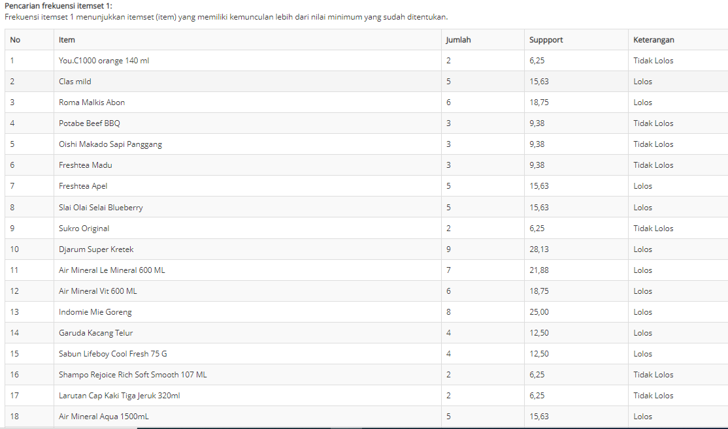

**Gambar 5.6 Hasil Perhitungan Aplikasi Menentukan *Frequent Itemset* 1**

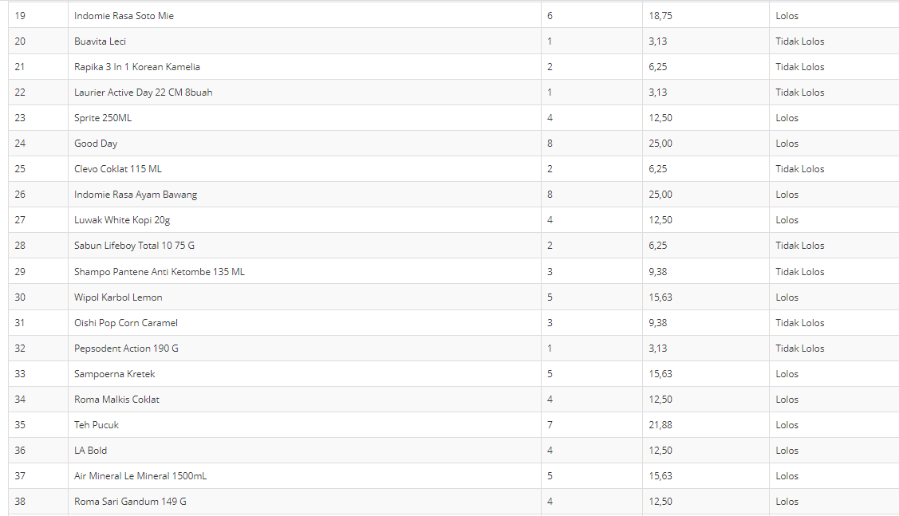

**Gambar 5.7 Hasil Perhitungan Aplikasi Menentukan *Frequent Itemset* 1 (Lanjutan)**

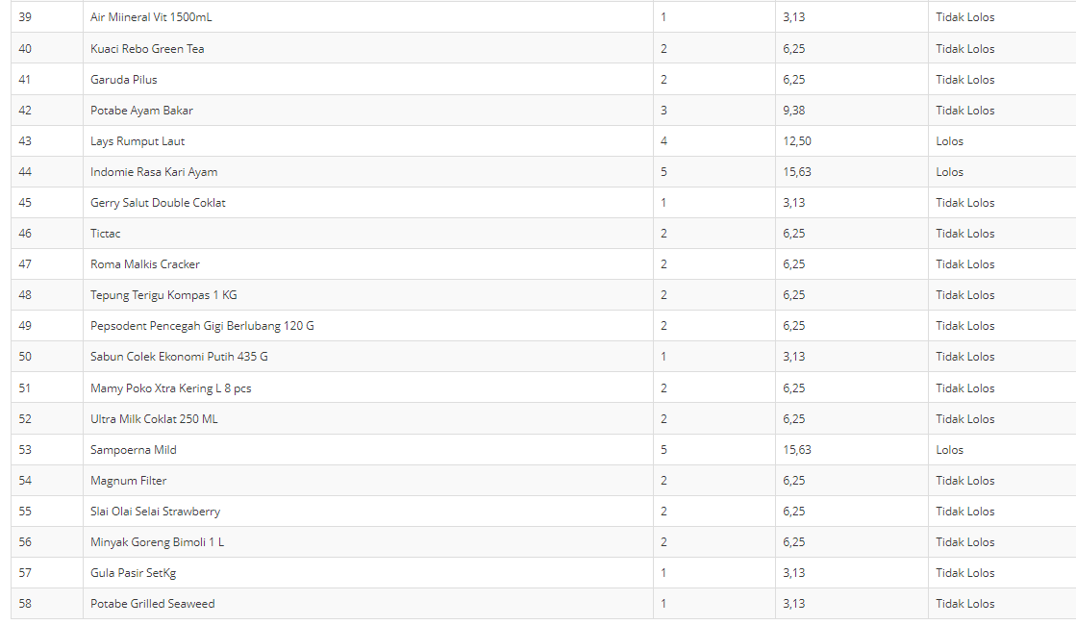

**Gambar 5.8 Hasil Perhitungan Aplikasi Menentukan *Frequent Itemset* 1 (Lanjutan)**

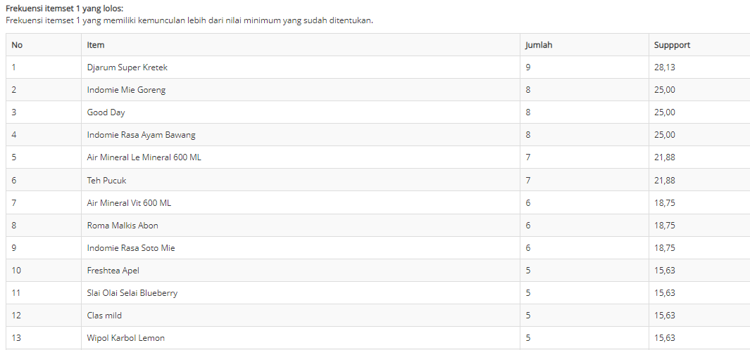

**Gambar 5.9 Hasil Perhitungan Aplikasi Itemset 1 yang Lolos**

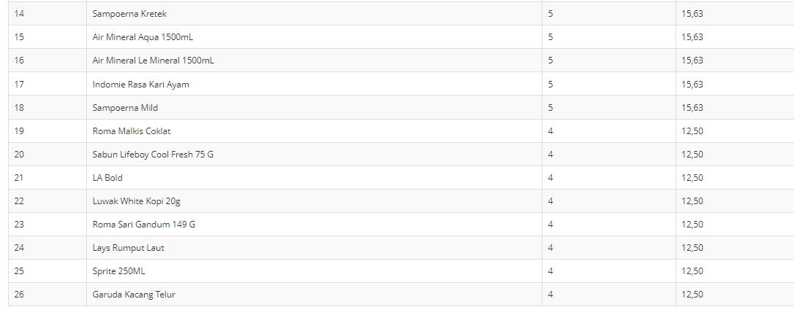

**Gambar 5.10 Hasil Perhitungan Aplikasi Itemset 1 yang Lolos (Lanjutan)**

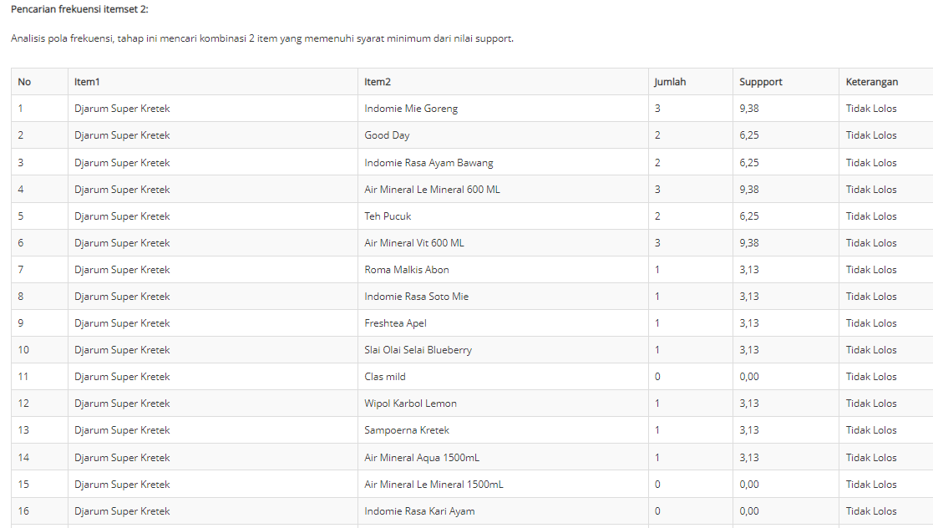

**Gambar 5.11 Hasil Perhitungan Aplikasi Menentukan *Frequent Itemset 2***

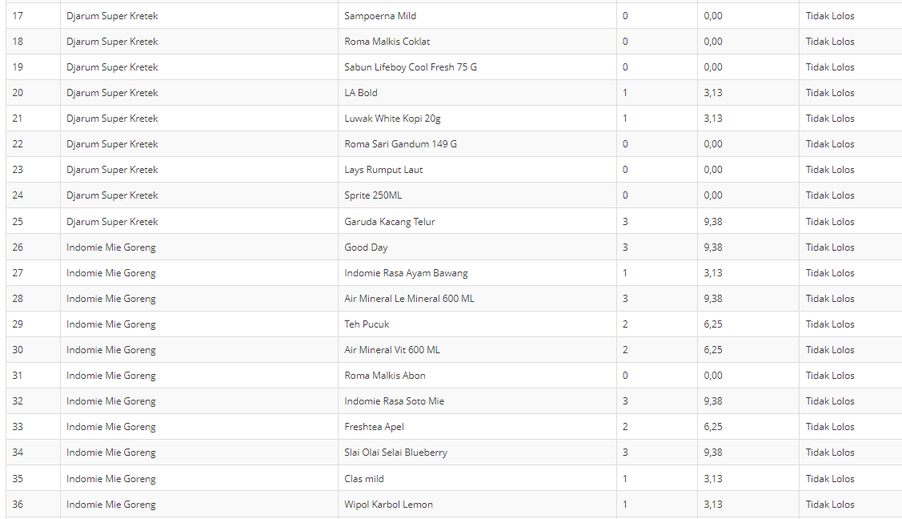

**Gambar 5.12 Hasil Perhitungan Aplikasi Menentukan *Frequent Itemset 2* (Lanjutan)**

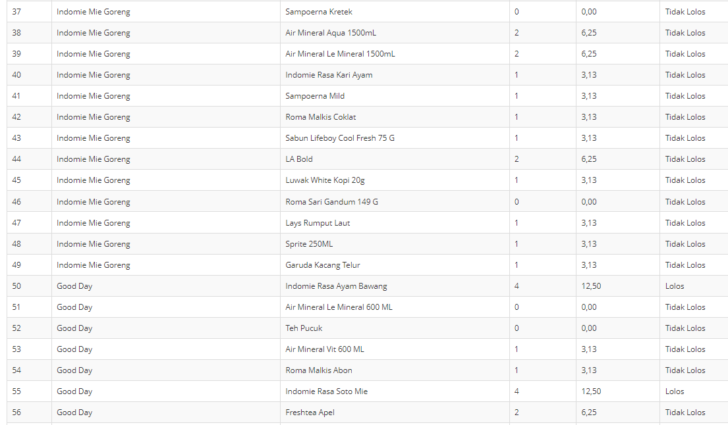

**Gambar 5.13 Hasil Perhitungan Aplikasi Menentukan *Frequent Itemset 2* (Lanjutan)**

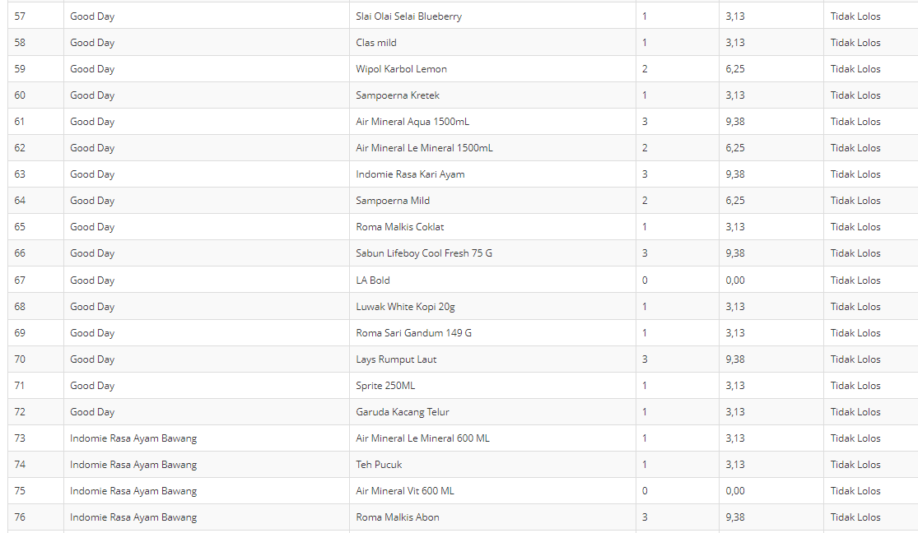

**Gambar 5.14 Hasil Perhitungan Aplikasi Menentukan *Frequent Itemset 2* (Lanjutan)**

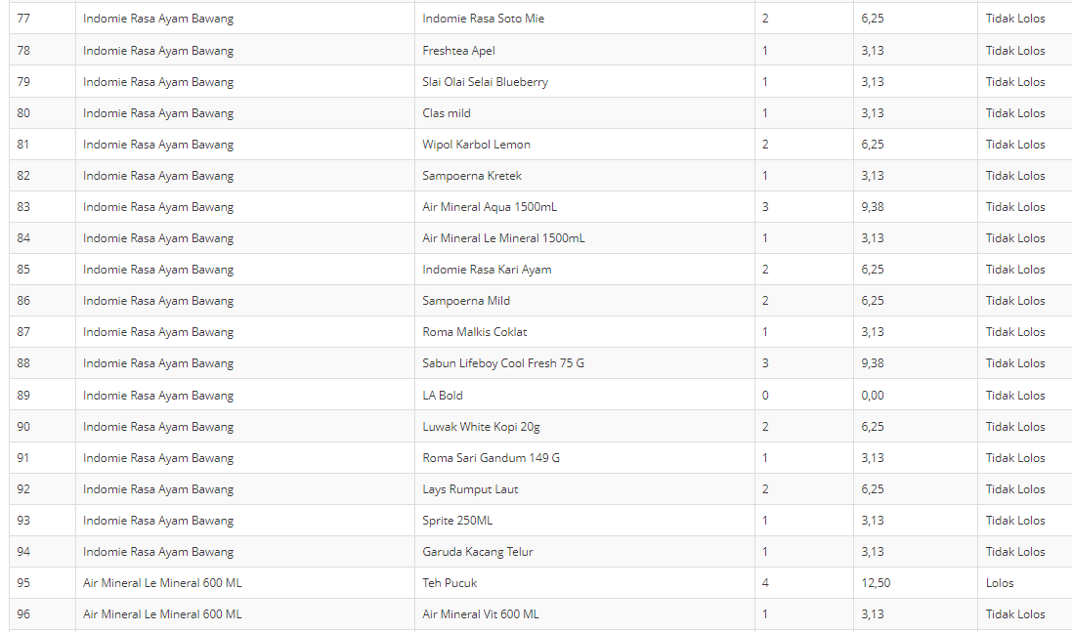

**Gambar 5.15 Hasil Perhitungan Aplikasi Menentukan *Frequent Itemset 2* (Lanjutan)**

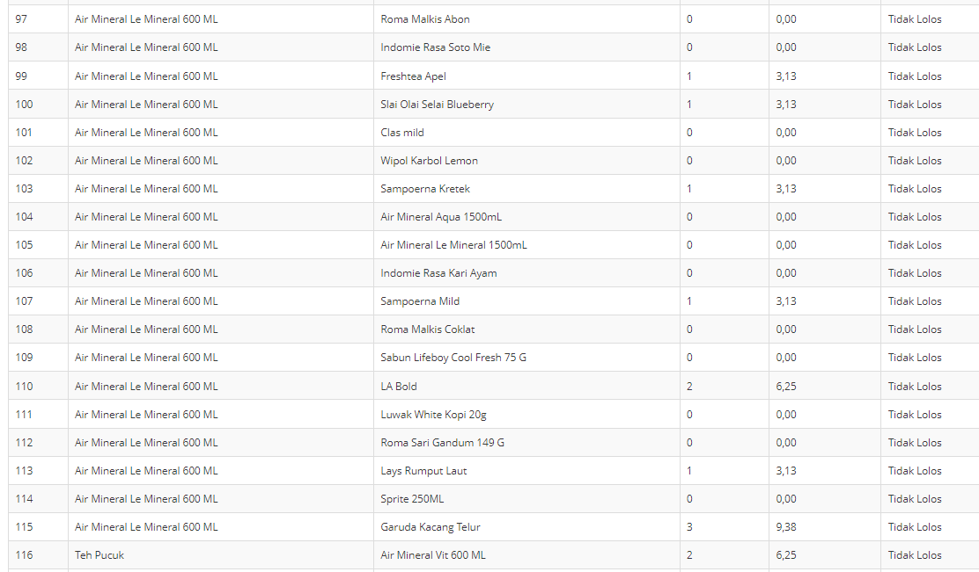

**Gambar 5.16 Hasil Perhitungan Aplikasi Menentukan *Frequent Itemset 2* (Lanjutan)**

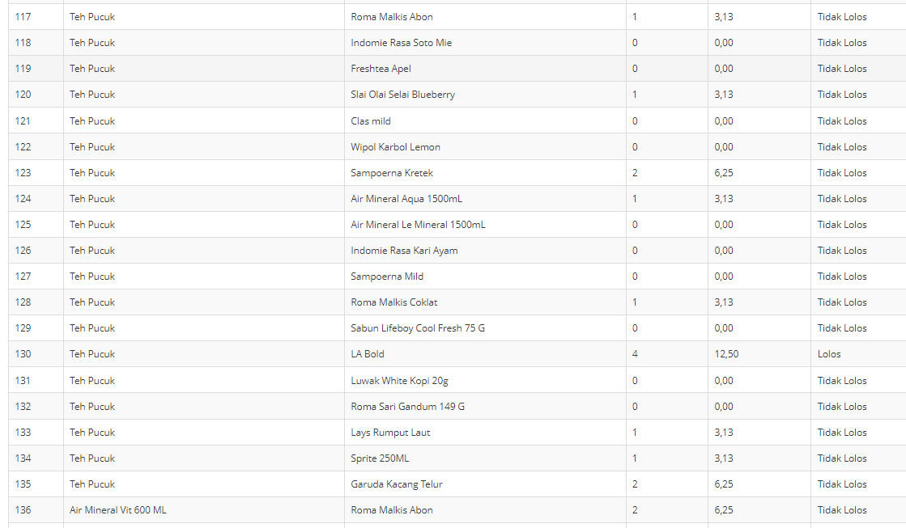

**Gambar 5.17 Hasil Perhitungan Aplikasi Menentukan *Frequent Itemset 2* (Lanjutan)**

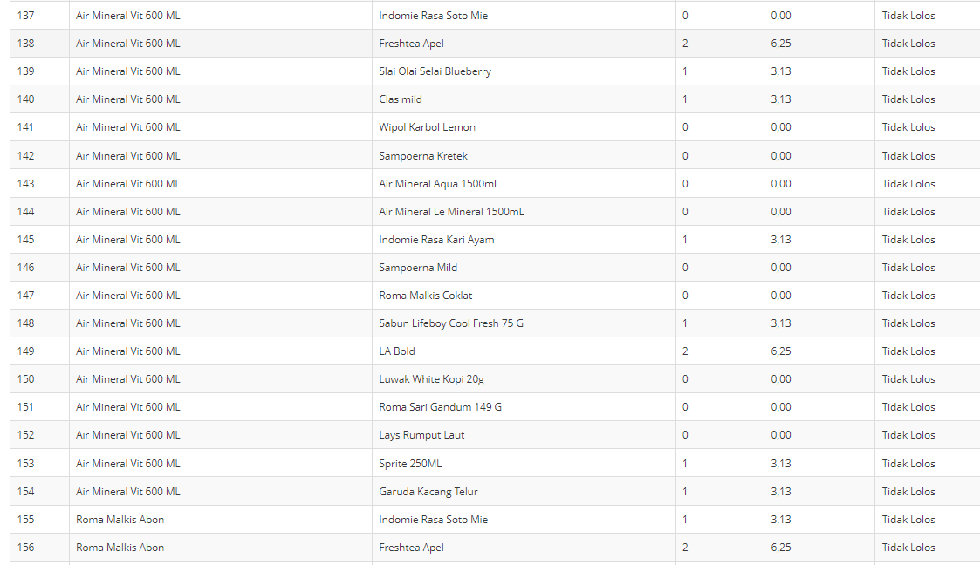

**Gambar 5.18 Hasil Perhitungan Aplikasi Menentukan *Frequent Itemset 2* (Lanjutan)**

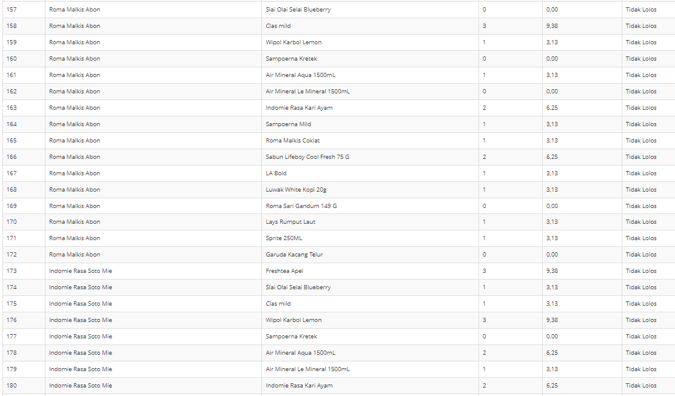

**Gambar 5.19 Hasil Perhitungan Aplikasi Menentukan *Frequent Itemset 2* (Lanjutan)**

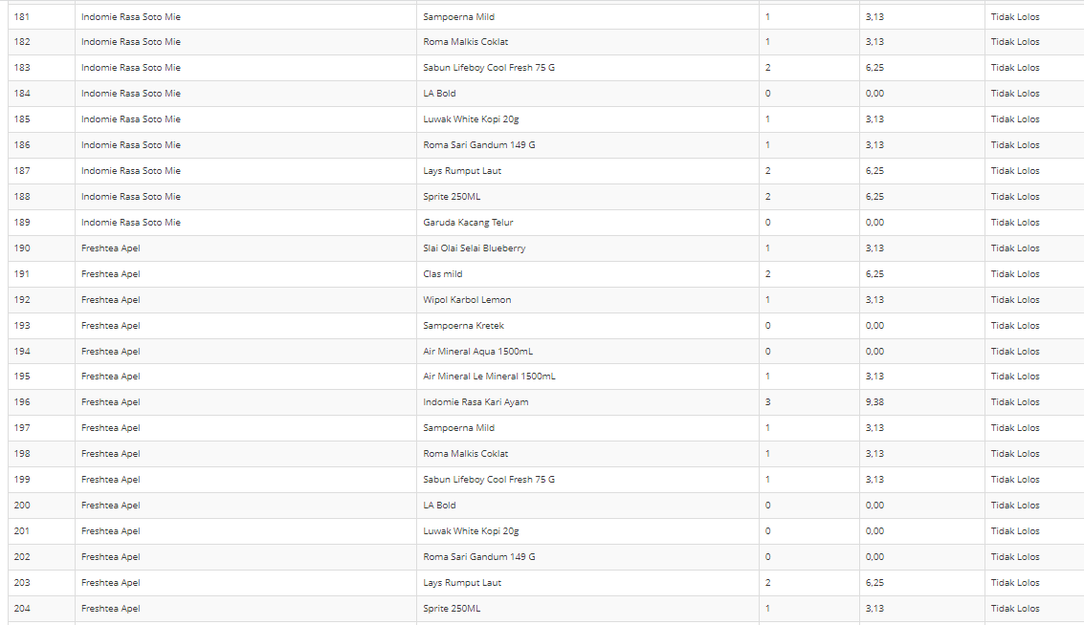

**Gambar 5.20 Hasil Perhitungan Aplikasi Menentukan *Frequent Itemset 2* (Lanjutan)**

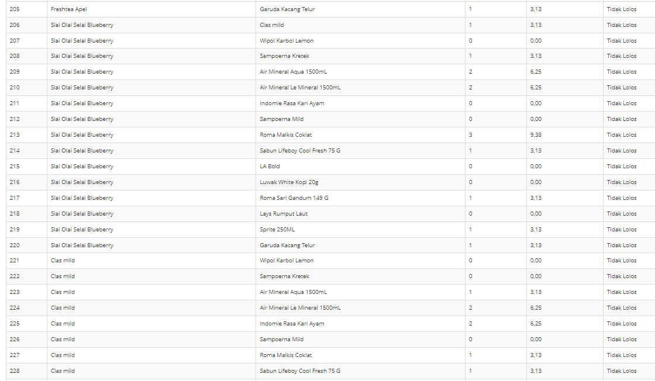

**Gambar 5.21 Hasil Perhitungan Aplikasi Menentukan *Frequent Itemset 2* (Lanjutan)**

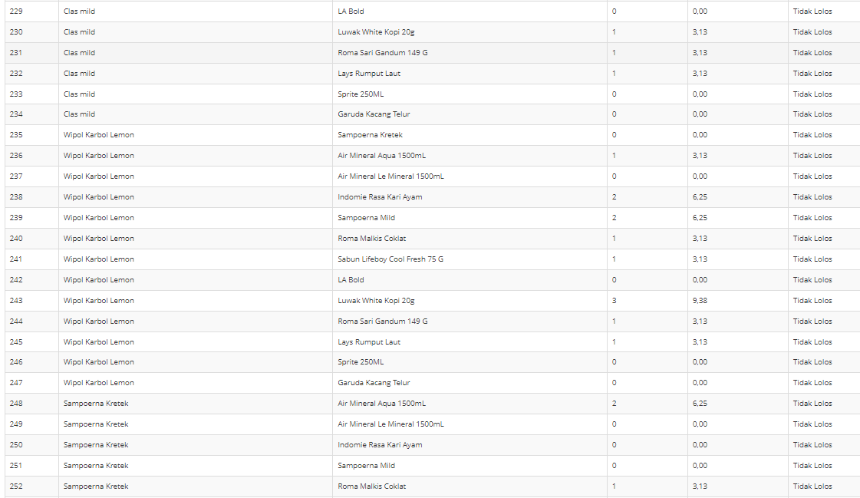

**Gambar 5.22 Hasil Perhitungan Aplikasi Menentukan *Frequent Itemset 2* (Lanjutan)**

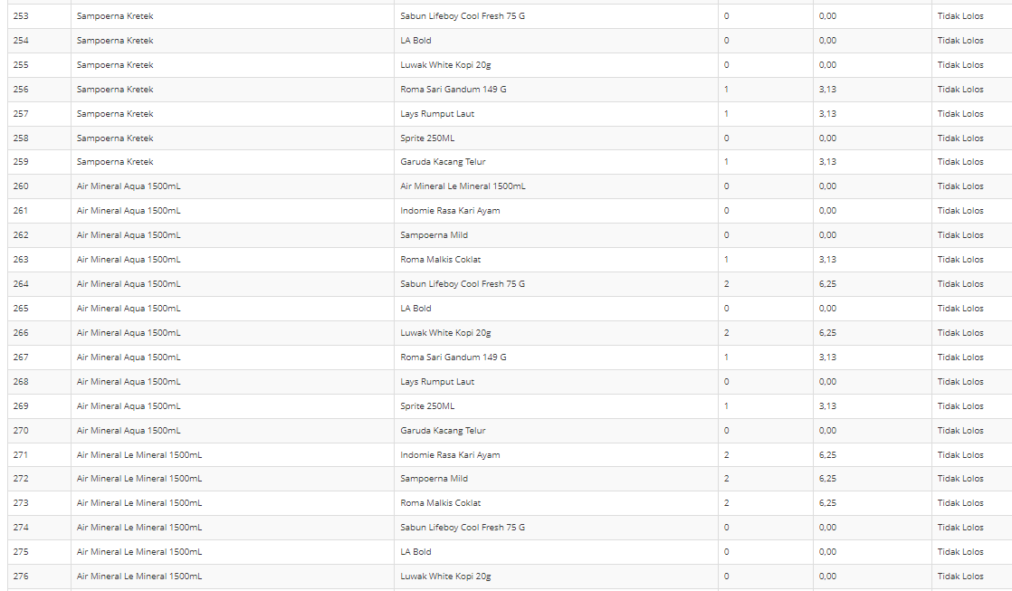

**Gambar 5.23 Hasil Perhitungan Aplikasi Menentukan *Frequent Itemset 2* (Lanjutan)**

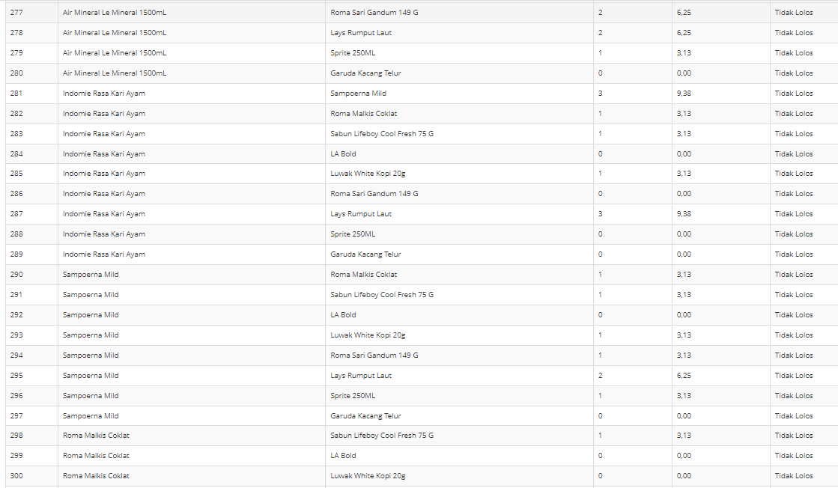

**Gambar 5.24 Hasil Perhitungan Aplikasi Menentukan *Frequent Itemset 2* (Lanjutan)**

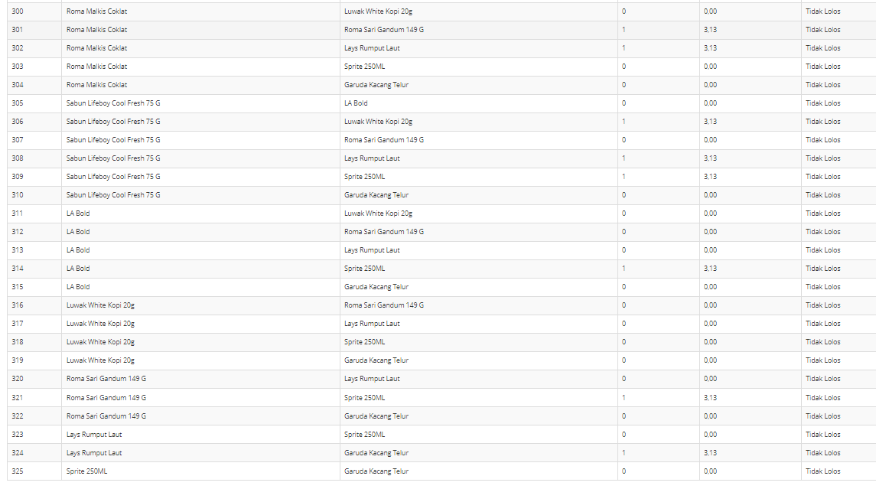

**Gambar 5.25 Hasil Perhitungan Aplikasi Menentukan *Frequent Itemset 2* (Lanjutan)**

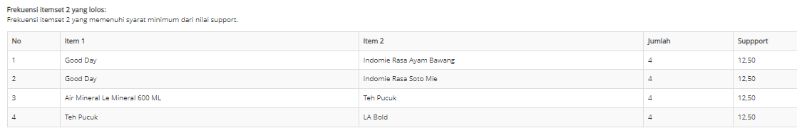

**Gambar 5.26 Hasil Perhitungan Aplikasi Itemset 2 yang Lolos**

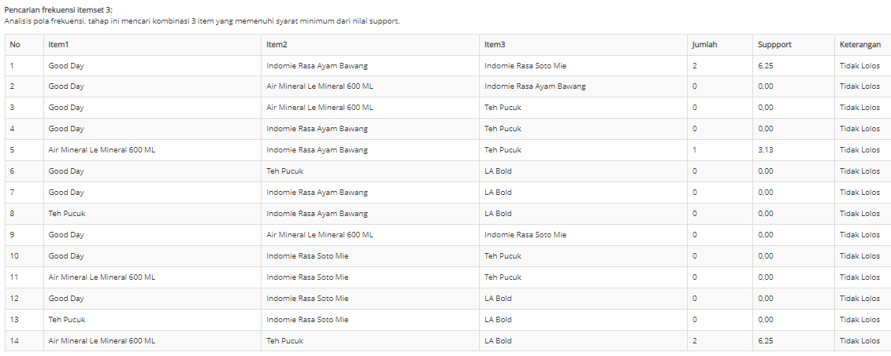

**Gambar 5.27 Hasil Perhitungan Aplikasi Menentukan *Frequent Itemset 3***

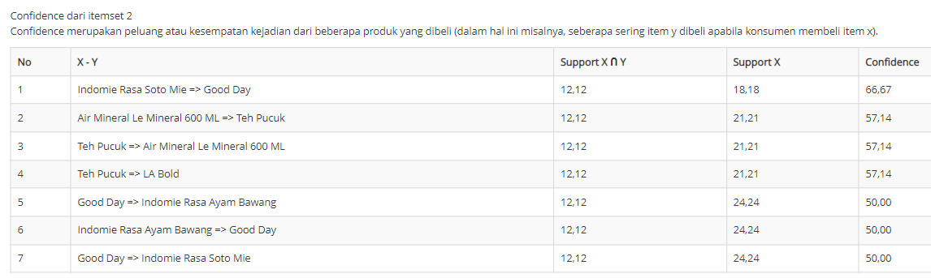

**Gambar 5.28 Hasil Perhitungan Aplikasi Analisis Hasil Pengaruh *Minimum* *confidence***

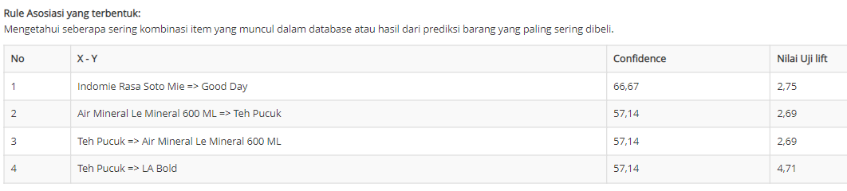

**Gambar 5.29 Hasil Perhitungan Aplikasi Mengukur kekuatan aturan Association Rule menggunakan Lift Rasio**

**Tabel 5.11 Hasil Perhitungan Manual Menentukan *Frequent Itemset***

|  |  |  |  |
| --- | --- | --- | --- |
| **NO** | **NAMA BARANG** | **TOTAL TRANSAKSI** | **SUPPORT(%)** |
| 1 | Minyak Goreng Bimoli 1 L | 2 | 6,25 |
| 2 | Gula Pasir SetKg | 1 | 3,13 |
| 3 | Tepung Terigu Kompas 1 KG | 2 | 6,25 |
| 4 | Luwak White Kopi 20g | 4 | 12,50 |
| 5 | Garuda Kacang Telur | 4 | 12,50 |
| 6 | Oishi Makado Sapi Panggang | 3 | 9,38 |
| 7 | Potabe Ayam Bakar | 3 | 9,38 |
| 8 | Potabe Beef BBQ | 3 | 9,38 |
| 9 | Roma Malkis Abon | 6 | 18,75 |
| 10 | Roma Malkis Cracker | 2 | 6,25 |
| 11 | Slai Olai Selai Strawberry | 2 | 6,25 |
| 12 | Tictac | 2 | 6,25 |
| 13 | Indomie Mie Goreng | 8 | 25,00 |
| 14 | Indomie Rasa Ayam Bawang | 8 | 25,00 |
| 15 | Clevo Coklat 115 ML | 2 | 6,25 |
| 16 | Good Day | 8 | 25,00 |
| 17 | Air Mineral Vit 600 ML | 6 | 18,75 |
| 18 | Air Mineral Le Mineral 600 ML | 7 | 21,88 |
| 19 | Teh Pucuk | 7 | 21,88 |
| 20 | Sprite 250ML | 4 | 12,50 |
| 21 | You.C1000 orange 140 ml | 2 | 6,25 |
| 22 | Laurier Active Day 22 CM 8buah | 1 | 3,13 |
| 23 | Rapika 3 In 1 Korean Kamelia | 2 | 6,25 |
| 24 | Pepsodent Action 190 G | 1 | 3,13 |
| 25 | LA Bold | 4 | 12,50 |
| 26 | Djarum Super Kretek | 9 | 28,13 |
| 27 | Clas mild | 5 | 15,63 |
| 28 | Sampoerna Kretek | 5 | 15,63 |
| 29 | Magnum Filter | 2 | 6,25 |
| 30 | Sampoerna Mild | 5 | 15,63 |
| 31 | Ultra Milk Coklat 250 ML | 2 | 6,25 |
| 32 | Buavita Leci | 1 | 3,13 |
| 33 | Sukro Original | 2 | 6,25 |
| 34 | Garuda Pilus | 2 | 6,25 |
| 35 | Lays Rumput Laut | 4 | 12,50 |
| 36 | Oishi Pop Corn Caramel | 3 | 9,38 |
| 37 | Potabe Grilled Seaweed | 1 | 3,13 |
| 38 | Roma Malkis Coklat | 4 | 12,50 |
| 39 | Kuaci Rebo Green Tea | 2 | 6,25 |
| 40 | Roma Sari Gandum 149 G | 4 | 12,50 |
| 41 | Gerry Salut Double Coklat | 1 | 3,13 |
| 42 | Slai Olai Selai Blueberry | 5 | 15,63 |
| 43 | Indomie Rasa Kari Ayam | 5 | 15,63 |
| 44 | Indomie Rasa Soto Mie | 6 | 18,75 |
| 45 | Air Mineral Aqua 1500mL | 5 | 15,63 |
| 46 | Air Mineral Le Mineral 1500mL | 5 | 15,63 |
| 47 | Air Miineral Vit 1500mL | 1 | 3,13 |
| 48 | Freshtea Apel | 5 | 15,63 |
| 49 | Freshtea Madu | 3 | 9,38 |
| 50 | Larutan Cap Kaki Tiga Jeruk 320ml | 2 | 6,25 |
| 51 | Sabun Colek Ekonomi Putih 435 G | 1 | 3,13 |
| 52 | Wipol Karbol Lemon | 5 | 15,63 |
| 53 | Pepsodent Pencegah Gigi Berlubang 120 G | 2 | 6,25 |
| 54 | Shampo Pantene Anti Ketombe 135 ML | 3 | 9,38 |
| 55 | Shampo Rejoice Rich Soft Smooth 107 ML | 2 | 6,25 |
| 56 | Sabun Lifeboy Cool Fresh 75 G | 4 | 12,50 |
| 57 | Sabun Lifeboy Total 10 75 G | 2 | 6,25 |
| 58 | Mamy Poko Xtra Kering L 8 pcs | 2 | 6,25 |

**Tabel 5.12 Hasil Perhitungan Manual Itemset 1 yang Lolos**

|  |  |  |  |
| --- | --- | --- | --- |
| **NO** | **NAMA BARANG** | **JUMLAH ITEMSET** | **SUPPORT(%)** |
| 1 | Luwak White Kopi 20g | 4 | 12,50 |
| 2 | Garuda Kacang Telur | 4 | 12,50 |
| 3 | Roma Malkis Abon | 6 | 18,75 |
| 4 | Indomie Mie Goreng | 8 | 25,00 |
| 5 | Indomie Rasa Ayam Bawang | 8 | 25,00 |
| 6 | Good Day | 8 | 25,00 |
| 7 | Air Mineral Vit 600 ML | 6 | 18,75 |
| 8 | Air Mineral Le Mineral 600 ML | 7 | 21,88 |
| 9 | Teh Pucuk | 7 | 21,88 |
| 10 | Sprite 250ML | 4 | 12,50 |
| 11 | LA Bold | 4 | 12,50 |
| 12 | Djarum Super Kretek | 9 | 28,13 |
| 13 | Clas mild | 5 | 15,63 |
| 14 | Sampoerna Kretek | 5 | 15,63 |
| 15 | Sampoerna Mild | 5 | 15,63 |
| 16 | Lays Rumput Laut | 4 | 12,50 |
| 17 | Roma Malkis Coklat | 4 | 12,50 |
| 18 | Roma Sari Gandum 149 G | 4 | 12,50 |
| 19 | Slai Olai Selai Blueberry | 5 | 15,63 |
| 20 | Indomie Rasa Kari Ayam | 5 | 15,63 |
| 21 | Indomie Rasa Soto Mie | 6 | 18,75 |
| 22 | Air Mineral Aqua 1500mL | 5 | 15,63 |
| 23 | Air Mineral Le Mineral 1500mL | 5 | 15,63 |
| 24 | Freshtea Apel | 5 | 15,63 |
| 25 | Wipol Karbol Lemon | 5 | 15,63 |
| 26 | Sabun Lifeboy Cool Fresh 75 G | 4 | 12,50 |

**Tabel 5.13 Hasil Perhitungan Manual Menentukan *Frequent Itemset 2***

|  |  |  |  |  |
| --- | --- | --- | --- | --- |
| **NO** | **ITEMSET** | | **JUMLAH ITEMSET** | **SUPPORT(%)** |
| 1 | Djarum Super Kretek | Indomie Mie Goreng | 3 | 9,38 |
| 2 | Djarum Super Kretek | Good Day | 2 | 6,25 |
| 3 | Djarum Super Kretek | Indomie Rasa Ayam Bawang | 2 | 6,25 |
| 4 | Djarum Super Kretek | Air Mineral Le Mineral 600 ML | 3 | 9,38 |
| 5 | Djarum Super Kretek | Teh Pucuk | 2 | 6,25 |
| 6 | Djarum Super Kretek | Air Mineral Vit 600 ML | 3 | 9,38 |
| 7 | Djarum Super Kretek | Roma Malkis Abon | 1 | 3,13 |
| 8 | Djarum Super Kretek | Indomie Rasa Soto Mie | 1 | 3,13 |
| 9 | Djarum Super Kretek | Freshtea Apel | 1 | 3,13 |
| 10 | Djarum Super Kretek | Slai Olai Selai Blueberry | 1 | 3,13 |
| 11 | Djarum Super Kretek | Clas mild | 0 | 0,00 |
| 12 | Djarum Super Kretek | Wipol Karbol Lemon | 1 | 3,13 |
| 13 | Djarum Super Kretek | Sampoerna Kretek | 1 | 3,13 |
| 14 | Djarum Super Kretek | Air Mineral Aqua 1500mL | 1 | 3,13 |
| 15 | Djarum Super Kretek | Air Mineral Le Mineral 1500mL | 0 | 0,00 |
| 16 | Djarum Super Kretek | Indomie Rasa Kari Ayam | 0 | 0,00 |
| 17 | Djarum Super Kretek | Sampoerna Mild | 0 | 0,00 |
| 18 | Djarum Super Kretek | Roma Malkis Coklat | 0 | 0,00 |
| 19 | Djarum Super Kretek | Sabun Lifeboy Cool Fresh 75 G | 0 | 0,00 |
| 20 | Djarum Super Kretek | LA Bold | 1 | 3,13 |
| 21 | Djarum Super Kretek | Luwak White Kopi 20g | 1 | 3,13 |
| 22 | Djarum Super Kretek | Roma Sari Gandum 149 G | 0 | 0,00 |
| 23 | Djarum Super Kretek | Lays Rumput Laut | 0 | 0,00 |
| 24 | Djarum Super Kretek | Sprite 250ML | 0 | 0,00 |
| 25 | Djarum Super Kretek | Garuda Kacang Telur | 3 | 9,38 |
| 26 | Indomie Mie Goreng | Good Day | 3 | 9,38 |
| 27 | Indomie Mie Goreng | Indomie Rasa Ayam Bawang | 1 | 3,13 |
| 28 | Indomie Mie Goreng | Air Mineral Le Mineral 600 ML | 3 | 9,38 |
| 29 | Indomie Mie Goreng | Teh Pucuk | 2 | 6,25 |
| 30 | Indomie Mie Goreng | Air Mineral Vit 600 ML | 2 | 6,25 |
| 31 | Indomie Mie Goreng | Roma Malkis Abon | 0 | 0,00 |
| 32 | Indomie Mie Goreng | Indomie Rasa Soto Mie | 3 | 9,38 |
| 33 | Indomie Mie Goreng | Freshtea Apel | 2 | 6,25 |
| 34 | Indomie Mie Goreng | Slai Olai Selai Blueberry | 3 | 9,38 |
| 35 | Indomie Mie Goreng | Clas mild | 1 | 3,13 |
| 36 | Indomie Mie Goreng | Wipol Karbol Lemon | 1 | 3,13 |
| 37 | Indomie Mie Goreng | Sampoerna Kretek | 0 | 0,00 |
| 38 | Indomie Mie Goreng | Air Mineral Aqua 1500mL | 2 | 6,25 |
| 39 | Indomie Mie Goreng | Air Mineral Le Mineral 1500mL | 2 | 6,25 |
| 40 | Indomie Mie Goreng | Indomie Rasa Kari Ayam | 1 | 3,13 |
| 41 | Indomie Mie Goreng | Sampoerna Mild | 1 | 3,13 |
| 42 | Indomie Mie Goreng | Roma Malkis Coklat | 1 | 3,13 |
| 43 | Indomie Mie Goreng | Sabun Lifeboy Cool Fresh 75 G | 1 | 3,13 |
| 44 | Indomie Mie Goreng | LA Bold | 2 | 6,25 |
| 45 | Indomie Mie Goreng | Luwak White Kopi 20g | 1 | 3,13 |
| 46 | Indomie Mie Goreng | Roma Sari Gandum 149 G | 0 | 0,00 |
| 47 | Indomie Mie Goreng | Lays Rumput Laut | 1 | 3,13 |
| 48 | Indomie Mie Goreng | Sprite 250ML | 1 | 3,13 |
| 49 | Indomie Mie Goreng | Garuda Kacang Telur | 1 | 3,13 |
| 50 | Good Day | Indomie Rasa Ayam Bawang | 4 | 12,50 |
| 51 | Good Day | Air Mineral Le Mineral 600 ML | 0 | 0,00 |
| 52 | Good Day | Teh Pucuk | 0 | 0,00 |
| 53 | Good Day | Air Mineral Vit 600 ML | 1 | 3,13 |
| 54 | Good Day | Roma Malkis Abon | 1 | 3,13 |
| 55 | Good Day | Indomie Rasa Soto Mie | 4 | 12,50 |
| 56 | Good Day | Freshtea Apel | 2 | 6,25 |
| 57 | Good Day | Slai Olai Selai Blueberry | 1 | 3,13 |
| 58 | Good Day | Clas mild | 1 | 3,13 |
| 59 | Good Day | Wipol Karbol Lemon | 2 | 6,25 |
| 60 | Good Day | Sampoerna Kretek | 1 | 3,13 |
| 61 | Good Day | Air Mineral Aqua 1500mL | 3 | 9,38 |
| 62 | Good Day | Air Mineral Le Mineral 1500mL | 2 | 6,25 |
| 63 | Good Day | Indomie Rasa Kari Ayam | 3 | 9,38 |
| 64 | Good Day | Sampoerna Mild | 2 | 6,25 |
| 65 | Good Day | Roma Malkis Coklat | 1 | 3,13 |
| 66 | Good Day | Sabun Lifeboy Cool Fresh 75 G | 3 | 9,38 |
| 67 | Good Day | LA Bold | 0 | 0,00 |
| 68 | Good Day | Luwak White Kopi 20g | 1 | 3,13 |
| 69 | Good Day | Roma Sari Gandum 149 G | 1 | 3,13 |
| 70 | Good Day | Lays Rumput Laut | 3 | 9,38 |
| 71 | Good Day | Sprite 250ML | 1 | 3,13 |
| 72 | Good Day | Garuda Kacang Telur | 1 | 3,13 |
| 73 | Indomie Rasa Ayam Bawang | Air Mineral Le Mineral 600 ML | 1 | 3,13 |
| 74 | Indomie Rasa Ayam Bawang | Teh Pucuk | 1 | 3,13 |
| 75 | Indomie Rasa Ayam Bawang | Air Mineral Vit 600 ML | 0 | 0,00 |
| 76 | Indomie Rasa Ayam Bawang | Roma Malkis Abon | 3 | 9,38 |
| 77 | Indomie Rasa Ayam Bawang | Indomie Rasa Soto Mie | 2 | 6,25 |
| 78 | Indomie Rasa Ayam Bawang | Freshtea Apel | 1 | 3,13 |
| 79 | Indomie Rasa Ayam Bawang | Slai Olai Selai Blueberry | 1 | 3,13 |
| 80 | Indomie Rasa Ayam Bawang | Clas mild | 1 | 3,13 |
| 81 | Indomie Rasa Ayam Bawang | Wipol Karbol Lemon | 2 | 6,25 |
| 82 | Indomie Rasa Ayam Bawang | Sampoerna Kretek | 1 | 3,13 |
| 83 | Indomie Rasa Ayam Bawang | Air Mineral Aqua 1500mL | 3 | 9,38 |
| 84 | Indomie Rasa Ayam Bawang | Air Mineral Le Mineral 1500mL | 1 | 3,13 |
| 85 | Indomie Rasa Ayam Bawang | Indomie Rasa Kari Ayam | 2 | 6,25 |
| 86 | Indomie Rasa Ayam Bawang | Sampoerna Mild | 2 | 6,25 |
| 87 | Indomie Rasa Ayam Bawang | Roma Malkis Coklat | 1 | 3,13 |
| 88 | Indomie Rasa Ayam Bawang | Sabun Lifeboy Cool Fresh 75 G | 3 | 9,38 |
| 89 | Indomie Rasa Ayam Bawang | LA Bold | 0 | 0,00 |
| 90 | Indomie Rasa Ayam Bawang | Luwak White Kopi 20g | 2 | 6,25 |
| 91 | Indomie Rasa Ayam Bawang | Roma Sari Gandum 149 G | 1 | 3,13 |
| 92 | Indomie Rasa Ayam Bawang | Lays Rumput Laut | 2 | 6,25 |
| 93 | Indomie Rasa Ayam Bawang | Sprite 250ML | 1 | 3,13 |
| 94 | Indomie Rasa Ayam Bawang | Garuda Kacang Telur | 1 | 3,13 |
| 95 | Air Mineral Le Mineral 600 ML | Teh Pucuk | 4 | 12,50 |
| 96 | Air Mineral Le Mineral 600 ML | Air Mineral Vit 600 ML | 1 | 3,13 |
| 97 | Air Mineral Le Mineral 600 ML | Roma Malkis Abon | 0 | 0,00 |
| 98 | Air Mineral Le Mineral 600 ML | Indomie Rasa Soto Mie | 0 | 0,00 |
| 99 | Air Mineral Le Mineral 600 ML | Freshtea Apel | 1 | 3,13 |
| 100 | Air Mineral Le Mineral 600 ML | Slai Olai Selai Blueberry | 1 | 3,13 |
| 101 | Air Mineral Le Mineral 600 ML | Clas mild | 0 | 0,00 |
| 102 | Air Mineral Le Mineral 600 ML | Wipol Karbol Lemon | 0 | 0,00 |
| 103 | Air Mineral Le Mineral 600 ML | Sampoerna Kretek | 1 | 3,13 |
| 104 | Air Mineral Le Mineral 600 ML | Air Mineral Aqua 1500mL | 0 | 0,00 |
| 105 | Air Mineral Le Mineral 600 ML | Air Mineral Le Mineral 1500mL | 0 | 0,00 |
| 106 | Air Mineral Le Mineral 600 ML | Indomie Rasa Kari Ayam | 0 | 0,00 |
| 107 | Air Mineral Le Mineral 600 ML | Sampoerna Mild | 1 | 3,13 |
| 108 | Air Mineral Le Mineral 600 ML | Roma Malkis Coklat | 0 | 0,00 |
| 109 | Air Mineral Le Mineral 600 ML | Sabun Lifeboy Cool Fresh 75 G | 0 | 0,00 |
| 110 | Air Mineral Le Mineral 600 ML | LA Bold | 2 | 6,25 |
| 111 | Air Mineral Le Mineral 600 ML | Luwak White Kopi 20g | 0 | 0,00 |
| 112 | Air Mineral Le Mineral 600 ML | Roma Sari Gandum 149 G | 0 | 0,00 |
| 113 | Air Mineral Le Mineral 600 ML | Lays Rumput Laut | 1 | 3,13 |
| 114 | Air Mineral Le Mineral 600 ML | Sprite 250ML | 0 | 0,00 |
| 115 | Air Mineral Le Mineral 600 ML | Garuda Kacang Telur | 3 | 9,38 |
| 116 | Teh Pucuk | Air Mineral Vit 600 ML | 2 | 6,25 |
| 117 | Teh Pucuk | Roma Malkis Abon | 1 | 3,13 |
| 118 | Teh Pucuk | Indomie Rasa Soto Mie | 0 | 0,00 |
| 119 | Teh Pucuk | Freshtea Apel | 0 | 0,00 |
| 120 | Teh Pucuk | Slai Olai Selai Blueberry | 1 | 3,13 |
| 121 | Teh Pucuk | Clas mild | 0 | 0,00 |
| 122 | Teh Pucuk | Wipol Karbol Lemon | 0 | 0,00 |
| 123 | Teh Pucuk | Sampoerna Kretek | 2 | 6,25 |
| 124 | Teh Pucuk | Air Mineral Aqua 1500mL | 1 | 3,13 |
| 125 | Teh Pucuk | Air Mineral Le Mineral 1500mL | 0 | 0,00 |
| 126 | Teh Pucuk | Indomie Rasa Kari Ayam | 0 | 0,00 |
| 127 | Teh Pucuk | Sampoerna Mild | 0 | 0,00 |
| 128 | Teh Pucuk | Roma Malkis Coklat | 1 | 3,13 |
| 129 | Teh Pucuk | Sabun Lifeboy Cool Fresh 75 G | 0 | 0,00 |
| 130 | Teh Pucuk | LA Bold | 4 | 12,50 |
| 131 | Teh Pucuk | Luwak White Kopi 20g | 0 | 0,00 |
| 132 | Teh Pucuk | Roma Sari Gandum 149 G | 0 | 0,00 |
| 133 | Teh Pucuk | Lays Rumput Laut | 1 | 3,13 |
| 134 | Teh Pucuk | Sprite 250ML | 1 | 3,13 |
| 135 | Teh Pucuk | Garuda Kacang Telur | 2 | 6,25 |
| 136 | Air Mineral Vit 600 ML | Roma Malkis Abon | 2 | 6,25 |
| 137 | Air Mineral Vit 600 ML | Indomie Rasa Soto Mie | 0 | 0,00 |
| 138 | Air Mineral Vit 600 ML | Freshtea Apel | 2 | 6,25 |
| 139 | Air Mineral Vit 600 ML | Slai Olai Selai Blueberry | 1 | 3,13 |
| 140 | Air Mineral Vit 600 ML | Clas mild | 1 | 3,13 |
| 141 | Air Mineral Vit 600 ML | Wipol Karbol Lemon | 0 | 0,00 |
| 142 | Air Mineral Vit 600 ML | Sampoerna Kretek | 0 | 0,00 |
| 143 | Air Mineral Vit 600 ML | Air Mineral Aqua 1500mL | 0 | 0,00 |
| 144 | Air Mineral Vit 600 ML | Air Mineral Le Mineral 1500mL | 0 | 0,00 |
| 145 | Air Mineral Vit 600 ML | Indomie Rasa Kari Ayam | 1 | 3,13 |
| 146 | Air Mineral Vit 600 ML | Sampoerna Mild | 0 | 0,00 |
| 147 | Air Mineral Vit 600 ML | Roma Malkis Coklat | 0 | 0,00 |
| 148 | Air Mineral Vit 600 ML | Sabun Lifeboy Cool Fresh 75 G | 1 | 3,13 |
| 149 | Air Mineral Vit 600 ML | LA Bold | 2 | 6,25 |
| 150 | Air Mineral Vit 600 ML | Luwak White Kopi 20g | 0 | 0,00 |
| 151 | Air Mineral Vit 600 ML | Roma Sari Gandum 149 G | 0 | 0,00 |
| 152 | Air Mineral Vit 600 ML | Lays Rumput Laut | 0 | 0,00 |
| 153 | Air Mineral Vit 600 ML | Sprite 250ML | 1 | 3,13 |
| 154 | Air Mineral Vit 600 ML | Garuda Kacang Telur | 1 | 3,13 |
| 155 | Roma Malkis Abon | Indomie Rasa Soto Mie | 1 | 3,13 |
| 156 | Roma Malkis Abon | Freshtea Apel | 2 | 6,25 |
| 157 | Roma Malkis Abon | Slai Olai Selai Blueberry | 0 | 0,00 |
| 158 | Roma Malkis Abon | Clas mild | 3 | 9,38 |
| 159 | Roma Malkis Abon | Wipol Karbol Lemon | 1 | 3,13 |
| 160 | Roma Malkis Abon | Sampoerna Kretek | 0 | 0,00 |
| 161 | Roma Malkis Abon | Air Mineral Aqua 1500mL | 1 | 3,13 |
| 162 | Roma Malkis Abon | Air Mineral Le Mineral 1500mL | 0 | 0,00 |
| 163 | Roma Malkis Abon | Indomie Rasa Kari Ayam | 2 | 6,25 |
| 164 | Roma Malkis Abon | Sampoerna Mild | 1 | 3,13 |
| 165 | Roma Malkis Abon | Roma Malkis Coklat | 1 | 3,13 |
| 166 | Roma Malkis Abon | Sabun Lifeboy Cool Fresh 75 G | 2 | 6,25 |
| 167 | Roma Malkis Abon | LA Bold | 1 | 3,13 |
| 168 | Roma Malkis Abon | Luwak White Kopi 20g | 1 | 3,13 |
| 169 | Roma Malkis Abon | Roma Sari Gandum 149 G | 0 | 0,00 |
| 170 | Roma Malkis Abon | Lays Rumput Laut | 1 | 3,13 |
| 171 | Roma Malkis Abon | Sprite 250ML | 1 | 3,13 |
| 172 | Roma Malkis Abon | Garuda Kacang Telur | 0 | 0,00 |
| 173 | Indomie Rasa Soto Mie | Freshtea Apel | 3 | 9,38 |
| 174 | Indomie Rasa Soto Mie | Slai Olai Selai Blueberry | 1 | 3,13 |
| 175 | Indomie Rasa Soto Mie | Clas mild | 1 | 3,13 |
| 176 | Indomie Rasa Soto Mie | Wipol Karbol Lemon | 3 | 9,38 |
| 177 | Indomie Rasa Soto Mie | Sampoerna Kretek | 0 | 0,00 |
| 178 | Indomie Rasa Soto Mie | Air Mineral Aqua 1500mL | 2 | 6,25 |
| 179 | Indomie Rasa Soto Mie | Air Mineral Le Mineral 1500mL | 1 | 3,13 |
| 180 | Indomie Rasa Soto Mie | Indomie Rasa Kari Ayam | 2 | 6,25 |
| 181 | Indomie Rasa Soto Mie | Sampoerna Mild | 1 | 3,13 |
| 182 | Indomie Rasa Soto Mie | Roma Malkis Coklat | 1 | 3,13 |
| 183 | Indomie Rasa Soto Mie | Sabun Lifeboy Cool Fresh 75 G | 2 | 6,25 |
| 184 | Indomie Rasa Soto Mie | LA Bold | 0 | 0,00 |
| 185 | Indomie Rasa Soto Mie | Luwak White Kopi 20g | 1 | 3,13 |
| 186 | Indomie Rasa Soto Mie | Roma Sari Gandum 149 G | 1 | 3,13 |
| 187 | Indomie Rasa Soto Mie | Lays Rumput Laut | 2 | 6,25 |
| 188 | Indomie Rasa Soto Mie | Sprite 250ML | 2 | 6,25 |
| 189 | Indomie Rasa Soto Mie | Garuda Kacang Telur | 0 | 0,00 |
| 190 | Freshtea Apel | Slai Olai Selai Blueberry | 1 | 3,13 |
| 191 | Freshtea Apel | Clas mild | 2 | 6,25 |
| 192 | Freshtea Apel | Wipol Karbol Lemon | 1 | 3,13 |
| 193 | Freshtea Apel | Sampoerna Kretek | 0 | 0,00 |
| 194 | Freshtea Apel | Air Mineral Aqua 1500mL | 0 | 0,00 |
| 195 | Freshtea Apel | Air Mineral Le Mineral 1500mL | 1 | 3,13 |
| 196 | Freshtea Apel | Indomie Rasa Kari Ayam | 3 | 9,38 |
| 197 | Freshtea Apel | Sampoerna Mild | 1 | 3,13 |
| 198 | Freshtea Apel | Roma Malkis Coklat | 1 | 3,13 |
| 199 | Freshtea Apel | Sabun Lifeboy Cool Fresh 75 G | 1 | 3,13 |
| 200 | Freshtea Apel | LA Bold | 0 | 0,00 |
| 201 | Freshtea Apel | Luwak White Kopi 20g | 0 | 0,00 |
| 202 | Freshtea Apel | Roma Sari Gandum 149 G | 0 | 0,00 |
| 203 | Freshtea Apel | Lays Rumput Laut | 2 | 6,25 |
| 204 | Freshtea Apel | Sprite 250ML | 1 | 3,13 |
| 205 | Freshtea Apel | Garuda Kacang Telur | 1 | 3,13 |
| 206 | Slai Olai Selai Blueberry | Clas mild | 1 | 3,13 |
| 207 | Slai Olai Selai Blueberry | Wipol Karbol Lemon | 0 | 0,00 |
| 208 | Slai Olai Selai Blueberry | Sampoerna Kretek | 1 | 3,13 |
| 209 | Slai Olai Selai Blueberry | Air Mineral Aqua 1500mL | 2 | 6,25 |
| 210 | Slai Olai Selai Blueberry | Air Mineral Le Mineral 1500mL | 2 | 6,25 |
| 211 | Slai Olai Selai Blueberry | Indomie Rasa Kari Ayam | 0 | 0,00 |
| 212 | Slai Olai Selai Blueberry | Sampoerna Mild | 0 | 0,00 |
| 213 | Slai Olai Selai Blueberry | Roma Malkis Coklat | 3 | 9,38 |
| 214 | Slai Olai Selai Blueberry | Sabun Lifeboy Cool Fresh 75 G | 1 | 3,13 |
| 215 | Slai Olai Selai Blueberry | LA Bold | 0 | 0,00 |
| 216 | Slai Olai Selai Blueberry | Luwak White Kopi 20g | 0 | 0,00 |
| 217 | Slai Olai Selai Blueberry | Roma Sari Gandum 149 G | 1 | 3,13 |
| 218 | Slai Olai Selai Blueberry | Lays Rumput Laut | 0 | 0,00 |
| 219 | Slai Olai Selai Blueberry | Sprite 250ML | 1 | 3,13 |
| 220 | Slai Olai Selai Blueberry | Garuda Kacang Telur | 1 | 3,13 |
| 221 | Clas mild | Wipol Karbol Lemon | 0 | 0,00 |
| 222 | Clas mild | Sampoerna Kretek | 0 | 0,00 |
| 223 | Clas mild | Air Mineral Aqua 1500mL | 1 | 3,13 |
| 224 | Clas mild | Air Mineral Le Mineral 1500mL | 2 | 6,25 |
| 225 | Clas mild | Indomie Rasa Kari Ayam | 2 | 6,25 |
| 226 | Clas mild | Sampoerna Mild | 0 | 0,00 |
| 227 | Clas mild | Roma Malkis Coklat | 1 | 3,13 |
| 228 | Clas mild | Sabun Lifeboy Cool Fresh 75 G | 1 | 3,13 |
| 229 | Clas mild | LA Bold | 0 | 0,00 |
| 230 | Clas mild | Luwak White Kopi 20g | 1 | 3,13 |
| 231 | Clas mild | Roma Sari Gandum 149 G | 1 | 3,13 |
| 232 | Clas mild | Lays Rumput Laut | 1 | 3,13 |
| 233 | Clas mild | Sprite 250ML | 0 | 0,00 |
| 234 | Clas mild | Garuda Kacang Telur | 0 | 0,00 |
| 235 | Wipol Karbol Lemon | Sampoerna Kretek | 0 | 0,00 |
| 236 | Wipol Karbol Lemon | Air Mineral Aqua 1500mL | 1 | 3,13 |
| 237 | Wipol Karbol Lemon | Air Mineral Le Mineral 1500mL | 0 | 0,00 |
| 238 | Wipol Karbol Lemon | Indomie Rasa Kari Ayam | 2 | 6,25 |
| 239 | Wipol Karbol Lemon | Sampoerna Mild | 2 | 6,25 |
| 240 | Wipol Karbol Lemon | Roma Malkis Coklat | 1 | 3,13 |
| 241 | Wipol Karbol Lemon | Sabun Lifeboy Cool Fresh 75 G | 1 | 3,13 |
| 242 | Wipol Karbol Lemon | LA Bold | 0 | 0,00 |
| 243 | Wipol Karbol Lemon | Luwak White Kopi 20g | 3 | 9,38 |
| 244 | Wipol Karbol Lemon | Roma Sari Gandum 149 G | 1 | 3,13 |
| 245 | Wipol Karbol Lemon | Lays Rumput Laut | 1 | 3,13 |
| 246 | Wipol Karbol Lemon | Sprite 250ML | 0 | 0,00 |
| 247 | Wipol Karbol Lemon | Garuda Kacang Telur | 0 | 0,00 |
| 248 | Sampoerna Kretek | Air Mineral Aqua 1500mL | 2 | 6,25 |
| 249 | Sampoerna Kretek | Air Mineral Le Mineral 1500mL | 0 | 0,00 |
| 250 | Sampoerna Kretek | Indomie Rasa Kari Ayam | 0 | 0,00 |
| 251 | Sampoerna Kretek | Sampoerna Mild | 0 | 0,00 |
| 252 | Sampoerna Kretek | Roma Malkis Coklat | 1 | 3,13 |
| 253 | Sampoerna Kretek | Sabun Lifeboy Cool Fresh 75 G | 0 | 0,00 |
| 254 | Sampoerna Kretek | LA Bold | 0 | 0,00 |
| 255 | Sampoerna Kretek | Luwak White Kopi 20g | 0 | 0,00 |
| 256 | Sampoerna Kretek | Roma Sari Gandum 149 G | 1 | 3,13 |
| 257 | Sampoerna Kretek | Lays Rumput Laut | 1 | 3,13 |
| 258 | Sampoerna Kretek | Sprite 250ML | 0 | 0,00 |
| 259 | Sampoerna Kretek | Garuda Kacang Telur | 1 | 3,13 |
| 260 | Air Mineral Aqua 1500mL | Air Mineral Le Mineral 1500mL | 0 | 0,00 |
| 261 | Air Mineral Aqua 1500mL | Indomie Rasa Kari Ayam | 0 | 0,00 |
| 262 | Air Mineral Aqua 1500mL | Sampoerna Mild | 0 | 0,00 |
| 263 | Air Mineral Aqua 1500mL | Roma Malkis Coklat | 1 | 3,13 |
| 264 | Air Mineral Aqua 1500mL | Sabun Lifeboy Cool Fresh 75 G | 2 | 6,25 |
| 265 | Air Mineral Aqua 1500mL | LA Bold | 0 | 0,00 |
| 266 | Air Mineral Aqua 1500mL | Luwak White Kopi 20g | 2 | 6,25 |
| 267 | Air Mineral Aqua 1500mL | Roma Sari Gandum 149 G | 1 | 3,13 |
| 268 | Air Mineral Aqua 1500mL | Lays Rumput Laut | 0 | 0,00 |
| 269 | Air Mineral Aqua 1500mL | Sprite 250ML | 1 | 3,13 |
| 270 | Air Mineral Aqua 1500mL | Garuda Kacang Telur | 0 | 0,00 |
| 271 | Air Mineral Le Mineral 1500mL | Indomie Rasa Kari Ayam | 2 | 6,25 |
| 272 | Air Mineral Le Mineral 1500mL | Sampoerna Mild | 2 | 6,25 |
| 273 | Air Mineral Le Mineral 1500mL | Roma Malkis Coklat | 2 | 6,25 |
| 274 | Air Mineral Le Mineral 1500mL | Sabun Lifeboy Cool Fresh 75 G | 0 | 0,00 |
| 275 | Air Mineral Le Mineral 1500mL | LA Bold | 0 | 0,00 |
| 276 | Air Mineral Le Mineral 1500mL | Luwak White Kopi 20g | 0 | 0,00 |
| 277 | Air Mineral Le Mineral 1500mL | Roma Sari Gandum 149 G | 2 | 6,25 |
| 278 | Air Mineral Le Mineral 1500mL | Lays Rumput Laut | 2 | 6,25 |
| 279 | Air Mineral Le Mineral 1500mL | Sprite 250ML | 1 | 3,13 |
| 280 | Air Mineral Le Mineral 1500mL | Garuda Kacang Telur | 0 | 0,00 |
| 281 | Indomie Rasa Kari Ayam | Sampoerna Mild | 3 | 9,38 |
| 282 | Indomie Rasa Kari Ayam | Roma Malkis Coklat | 1 | 3,13 |
| 283 | Indomie Rasa Kari Ayam | Sabun Lifeboy Cool Fresh 75 G | 1 | 3,13 |
| 284 | Indomie Rasa Kari Ayam | LA Bold | 0 | 0,00 |
| 285 | Indomie Rasa Kari Ayam | Luwak White Kopi 20g | 1 | 3,13 |
| 286 | Indomie Rasa Kari Ayam | Roma Sari Gandum 149 G | 0 | 0,00 |
| 287 | Indomie Rasa Kari Ayam | Lays Rumput Laut | 3 | 9,38 |
| 288 | Indomie Rasa Kari Ayam | Sprite 250ML | 0 | 0,00 |
| 289 | Indomie Rasa Kari Ayam | Garuda Kacang Telur | 0 | 0,00 |
| 290 | Sampoerna Mild | Roma Malkis Coklat | 1 | 3,13 |
| 291 | Sampoerna Mild | Sabun Lifeboy Cool Fresh 75 G | 1 | 3,13 |
| 292 | Sampoerna Mild | LA Bold | 0 | 0,00 |
| 293 | Sampoerna Mild | Luwak White Kopi 20g | 1 | 3,13 |
| 294 | Sampoerna Mild | Roma Sari Gandum 149 G | 1 | 3,13 |
| 295 | Sampoerna Mild | Lays Rumput Laut | 2 | 6,25 |
| 296 | Sampoerna Mild | Sprite 250ML | 1 | 3,13 |
| 297 | Sampoerna Mild | Garuda Kacang Telur | 0 | 0,00 |
| 298 | Roma Malkis Coklat | Sabun Lifeboy Cool Fresh 75 G | 1 | 3,13 |
| 299 | Roma Malkis Coklat | LA Bold | 0 | 0,00 |
| 300 | Roma Malkis Coklat | Luwak White Kopi 20g | 0 | 0,00 |
| 301 | Roma Malkis Coklat | Roma Sari Gandum 149 G | 1 | 3,13 |
| 302 | Roma Malkis Coklat | Lays Rumput Laut | 1 | 3,13 |
| 303 | Roma Malkis Coklat | Sprite 250ML | 0 | 0,00 |
| 304 | Roma Malkis Coklat | Garuda Kacang Telur | 0 | 0,00 |
| 305 | Sabun Lifeboy Cool Fresh 75 G | LA Bold | 0 | 0,00 |
| 306 | Sabun Lifeboy Cool Fresh 75 G | Luwak White Kopi 20g | 1 | 3,13 |
| 307 | Sabun Lifeboy Cool Fresh 75 G | Roma Sari Gandum 149 G | 0 | 0,00 |
| 308 | Sabun Lifeboy Cool Fresh 75 G | Lays Rumput Laut | 1 | 3,13 |
| 309 | Sabun Lifeboy Cool Fresh 75 G | Sprite 250ML | 1 | 3,13 |
| 310 | Sabun Lifeboy Cool Fresh 75 G | Garuda Kacang Telur | 0 | 0,00 |
| 311 | LA Bold | Luwak White Kopi 20g | 0 | 0,00 |
| 312 | LA Bold | Roma Sari Gandum 149 G | 0 | 0,00 |
| 313 | LA Bold | Lays Rumput Laut | 0 | 0,00 |
| 314 | LA Bold | Sprite 250ML | 1 | 3,13 |
| 315 | LA Bold | Garuda Kacang Telur | 0 | 0,00 |
| 316 | Luwak White Kopi 20g | Roma Sari Gandum 149 G | 0 | 0,00 |
| 317 | Luwak White Kopi 20g | Lays Rumput Laut | 0 | 0,00 |
| 318 | Luwak White Kopi 20g | Sprite 250ML | 0 | 0,00 |
| 319 | Luwak White Kopi 20g | Garuda Kacang Telur | 0 | 0,00 |
| 320 | Roma Sari Gandum 149 G | Lays Rumput Laut | 0 | 0,00 |
| 321 | Roma Sari Gandum 149 G | Sprite 250ML | 1 | 3,13 |
| 322 | Roma Sari Gandum 149 G | Garuda Kacang Telur | 0 | 0,00 |
| 323 | Lays Rumput Laut | Sprite 250ML | 0 | 0,00 |
| 324 | Lays Rumput Laut | Garuda Kacang Telur | 1 | 3,13 |
| 325 | Sprite 250ML | Garuda Kacang Telur | 0 | 0,00 |

**Tabel 5.14 Hasil Perhitungan Manual *Itemset 2* yang Lolos**

|  |  |  |  |  |
| --- | --- | --- | --- | --- |
| **No** | **Item 1** | **Item 2** | **Jumlah** | **Suppport(%)** |
| 1 | Good Day | Indomie Rasa Ayam Bawang | 4 | 12,50 |
| 2 | Good Day | Indomie Rasa Soto Mie | 4 | 12,50 |
| 3 | Air Mineral Le Mineral 600 ML | Teh Pucuk | 4 | 12,50 |
| 4 | Teh Pucuk | LA Bold | 4 | 12,50 |

**Tabel 5.15 Hasil Perhitungan Manual Menentukan *Frequent Itemset 3***

|  |  |  |  |  |  |
| --- | --- | --- | --- | --- | --- |
| **NO** | **ITEMSET 1** | **ITEMSET 2** | **ITEMSET 3** | **JUMLAH ITEMSET** | **SUPPORT(%)** |
| 1 | Good Day | Indomie Rasa Ayam Bawang | Indomie Rasa Soto Mie | 2 | 6,25 |
| 2 | Good Day | Air Mineral Le Mineral 600 ML | Indomie Rasa Ayam Bawang | 0 | 0,00 |
| 3 | Good Day | Air Mineral Le Mineral 600 ML | Teh Pucuk | 0 | 0,00 |
| 4 | Good Day | Indomie Rasa Ayam Bawang | Teh Pucuk | 0 | 0,00 |
| 5 | Air Mineral Le Mineral 600 ML | Indomie Rasa Ayam Bawang | Teh Pucuk | 1 | 3,13 |
| 6 | Good Day | Teh Pucuk | LA Bold | 0 | 0,00 |
| 7 | Good Day | Indomie Rasa Ayam Bawang | LA Bold | 0 | 0,00 |
| 8 | Teh Pucuk | Indomie Rasa Ayam Bawang | LA Bold | 0 | 0,00 |
| 9 | Good Day | Air Mineral Le Mineral 600 ML | Indomie Rasa Soto Mie | 0 | 0,00 |
| 10 | Good Day | Indomie Rasa Soto Mie | Teh Pucuk | 0 | 0,00 |
| 11 | Air Mineral Le Mineral 600 ML | Indomie Rasa Soto Mie | Teh Pucuk | 0 | 0,00 |
| 12 | Good Day | Indomie Rasa Soto Mie | LA Bold | 0 | 0,00 |
| 13 | Teh Pucuk | Indomie Rasa Soto Mie | LA Bold | 0 | 0,00 |
| 14 | Air Mineral Le Mineral 600 ML | Teh Pucuk | LA Bold | 2 | 6,25 |

**Tabel 5.16 Hasil Perhitungan Manual Analisis Hasil Pengaruh *Minimum* *Confidence***

|  |  |  |
| --- | --- | --- |
| ***If antecedent then consequent*** | ***Support(%)*** | ***Confidance(%)*** |
| *If buy* Indomie Rasa Soto Mie, *then buy* Good Day | 12,50 | 66,67 |
| *If buy* Teh Pucuk, *then buy* LA Bold | 12,50 | 57,13 |
| *If buy* Teh Pucuk, *then buy* Air Mineral Le Mineral 600 ML | 12,50 | 57,13 |
| *If buy* Air Mineral Le Mineral 600 ML, *then buy* Teh Pucuk | 12,50 | 57,13 |
| *If buy* Good Day, *then buy* Indomie Rasa Soto Mie | 12,50 | 50,00 |
| *If buy* Indomie Rasa Ayam Bawang, *then buy* Good Day | 12,50 | 50,00 |
| *If buy* Good Day, *then buy* Indomie Rasa Ayam Bawang | 12,50 | 50,00 |

**Tabel 5.17 Hasil Perhitungan Manual Mengukur kekuatan aturan Association Rule menggunakan Lift Rasio**

|  |  |  |  |  |  |
| --- | --- | --- | --- | --- | --- |
| **ITEMSET** | | **SUPPORT(%)** | **CONFIDANCE(%)** | **LIFT RATIO** | **KETERANGAN** |
| Indomie Rasa Soto Mie | Good Day | 12,50 | 66,67 | 2,67 | Korelasi Positif |
| Teh Pucuk | LA Bold | 12,50 | 57,13 | 4,57 | Korelasi Positif |
| Teh Pucuk | Air Mineral Le Mineral 600 ML | 12,50 | 57,13 | 2,61 | Korelasi Positif |
| Air Mineral Le Mineral 600 ML | Teh Pucuk | 12,50 | 57,13 | 2,61 | Korelasi Positif |
| Good Day | Indomie Rasa Soto Mie | 12,50 | 50,00 | 2,67 | Korelasi Positif |
| Indomie Rasa Ayam Bawang | Good Day | 12,50 | 50,00 | 2,00 | Korelasi Positif |
| Good Day | Indomie Rasa Ayam Bawang | 12,50 | 50,00 | 2,00 | Korelasi Positif |

Pada Gambar 5.6 sampai Gambar 5.29 perhitungan aplikasi dan Tabel 5.11 sampai Tabel 5.17 perhitungan manual menunjukkan hasil yang sama dalam memprediksi barang yang paling laku atau yang sering di beli dengan mengimplementasikan metode *Association Rule* menggunakan algoritma *Apriori.*

* + 1. **Perbandingan Hasil Perhitungan Sistem Dan Data Sebenarnya (Aktual)**

Perhitungan akurasi prediksi barang paling laku atau yang paling sering dibeli oleh sistem dengan data sebenarnya (aktual) yang sudah dikonfirmasi di Toko Alisha Mart, dengan mengimplementasikan metode *Association Rule* menggunakan algoritma *Apriori.*

**Tabel 5.18 Perbandingan Perhitungan Sistem Dan Data Sebenarnya (Aktual) Minggu ke-7**

|  |  |
| --- | --- |
| **DATA AKTUAL MINGGU KE-7** | **HASIL PREDIKSI MINGGU KE-7** |
| Good Day | Good Day |
| Djarum Super Kretek | Djarum Super Kretek |
| Clevo Coklat 115 ML | Clevo Coklat 115 ML |
| Magnum Filter | Indomie Rasa Ayam Bawang |
| Teh Pucuk | Teh Pucuk |
| Indomie Mie Goreng | Indomie Mie Goreng |

Berdasarkan tabel 5.18 menunjukan hasil prediksi barang paling laku atau sering dibeli. Ada 6 item yang paling sering di beli, dan memiliki 1 item yang berbeda dari data aktual yang paling sering dibeli di minggu ke-7. Dengan hasil persentase kesamaan dengan data aktual yang dapat diselesaikan dengan persamaan 5.9, yaitu:

(5.9)

**Tabel 5.19 Perbandingan Perhitungan Sistem Dan Data Sebenarnya (Aktual) Minggu ke-8**

|  |  |
| --- | --- |
| **DATA AKTUAL MINGGU KE-8** | **HASIL PREDIKSI MINGGU KE-8** |
| Sampoerna Kretek | Indomie Rasa Ayam Bawang |
| Good Day | Good Day |
| Djarum Super Kretek | Djarum Super Kretek |
| Teh Pucuk | Teh Pucuk |

Berdasarkan tabel 5.19 menunjukan hasil prediksi barang paling laku atau sering dibeli ada 4 item yang paling sering di beli, dan memiliki 1 item yang berbeda dari data aktual yang paling sering dibeli di minggu ke-8. Dengan hasil persentase kesamaan dengan data aktual yang dapat diselesaikan dengan persamaan 5.10, yaitu:

(5.10)

**Tabel 5.20 Perbandingan Perhitungan Sistem Dan Data Sebenarnya (Aktual) Minggu ke-9**

|  |  |
| --- | --- |
| **DATA AKTUAL MINGGU KE-9** | **HASIL PREDIKSI MINGGU KE-9** |
| Djarum Super Kretek | Djarum Super Kretek |
| Good Day | Good Day |
| Clevo Coklat 115 ML | Clevo Coklat 115 ML |
| Teh Pucuk | Teh Pucuk |
| Magnum Filter | Sampoerna Kretek |

Berdasarkan tabel 5.20 menunjukan hasil prediksi barang paling laku atau sering dibeli ada 5 item yang paling sering di beli, dan memiliki 1 item yang berbeda dari data aktual yang paling sering dibeli di minggu ke-9. Dengan hasil persentase kesamaan dengan data aktual yang dapat diselesaikan dengan persamaan 5.11, yaitu:

(5.11)

**Tabel 5.21 Perbandingan Perhitungan Sistem Dan Data Sebenarnya (Aktual) Minggu ke-10**

|  |  |
| --- | --- |
| **DATA AKTUAL MINGGU KE-10** | **HASIL PREDIKSI MINGGU KE-10** |
| Good Day | Good Day |
| Clevo Coklat 115 ML | Clevo Coklat 115 ML |
| Magnum Filter | Magnum Filter |
| Indomie Mie Goreng | Indomie Mie Goreng |
| Indomie Rasa Ayam Bawang | Indomie Rasa Ayam Bawang |
| Sampoerna Kretek | Teh Pucuk |
| Gerry Salut Double Coklat | Djarum Super Kretek |

Berdasarkan tabel 5.21 menunjukan hasil prediksi barang paling laku atau sering dibeli ada 7 item yang paling sering di beli, dan memiliki 2 item yang berbeda dari data aktual yang paling sering dibeli di minggu ke-10. Dengan hasil persentase kesamaan dengan data aktual yang dapat diselesaikan dengan persamaan 5.12, yaitu:

(5.12)

Berdasarkan dari 4 persentase kesamaan diatas mempunyai rata – rata persentase kesamaan dengan data aktual, dapat diselesaikan dengan persamaan 5.16:

(5.16)

Maka, rata-rata akurasi prediksi barang paling laku atau yang paling sering dibeli di Toko Melta Swalayan dengan mengimplementasikan metode *Association Rule* menggunakan algoritma *Apriori* adalah 77,43%.